**LUMENS**

**A STRATEGIC ACTION GAME WITH LIGHT AND PHYSICS SIMULATION, AND EMERGENT ARTIFICIAL INTELLIGENCE**

**FINAL REPORT**

Eoghan O’Keeffe – BSc (Hon) Entertainment Systems – 08543453 – Project 30

INTRODUCTION 6

PART I – CONCEPT, DESIGN AND PLANNING 7

SECTION I – OVERVIEW 8

1 - Concept 8

2 - Game Flow Summary 8

3 - Feature Set 9

4 - Genre 9

5 - Look and Feel 9

6 - Target Audience 11

7 - Project Scope 11

SECTION II – GAMEPLAY AND MECHANICS 12

1 - Game-play 12

1.1 - Game Progression 12

1.2 - Objectives 12

1.3 - Challenges 12

1.4 - Game-play Flow 13

2 - Mechanics 15

2.1 - Physics 15

(a) Light 15

(b) Particles 15

(c) Rigid Bodies 15

(d) Soft Bodies 15

(e) Collisions 16

2.2 - Movement 16

2.3 - Combat 16

(a) Protagonist 16

− Normal 16

− Enhanced 17

∙ Beam 18

∙ Repel 18

∙ Range 19

(b) Antagonists 19

2.4 - Interactive Objects 20

(a) Collectibles 20

− Healer 20

− Score Multiplier Booster 20

− Light Dimmer 20

− Enhanced Combat Booster 21

(b) Atmosphere and Particles 21

2.5 - Environment 21

(a) Interaction 21

(b) Progression 21

(c) Stage Generation and Transitions 22

3 - Screen Flow 23

4 - Persistence 25

4.1 - Saving and Loading 25

4.2 - Scores 25

SECTION III – THEMES, SETTING, AND ENTITIES 26

1 - Themes 26

2 - Setting 26

2.1 - Elements 26

2.2 - Look and Feel 27

3 - Entities 27

3.1 - Protagonist 27

(a) Behaviour 27

(b) Statistics 28

(c) Look and Feel 28

3.2 - Antagonists 29

(a) Fly 29

− Behaviour 29

− Statistics 29

− Look and Feel 30

(b) Hunter 30

− Behaviour 30

− Statistics 30

− Look and Feel 31

(c) Strobe 31

− Behaviour 31

− Statistics 32

− Look and Feel 32

(d) Behemoth 32

− Behaviour 32

− Statistics 33

− Look and Feel 34

SECTION IV – USER INTERFACE 35

1 - Input System 35

1.1 - Keys and Pointer (Mouse and Keyboard) 35

1.2 - Pointers (Touch-screen) 35

1.3 - Buttons (Gamepad) 36

1.4 - Other 37

2 - Visual System 37

2.1 - Viewport 37

2.2 - Menus and Heads-Up-Display 37

2.3 - Screen Sizes and Orientation Changes 38

3 - Audio and Music 39

SECTION V – ARTIFICIAL INTELLIGENCE 40

1 - Antagonists 40

1.1 - Fly 40

1.2 - Hunter 40

1.3 - Strobe 41

1.4 - Behemoth 41

2 - Protagonist 42

SECTION VI – CONCEPT ART 43

SECTION VII – TECHNICAL 51

1 - Target Platforms and Considerations 51

1.1 - Modern Web Application 51

1.2 - iOS 51

1.3 - PSP 51

1.4 - Android 51

1.5 - Windows 51

1.6 - Mac OS 52

2 - Development Environment 52

2.1 - Programming Languages 52

2.2 - Software 52

2.3 - Hardware 52

SECTION VIII – INITIAL PROJECT MANAGEMENT AND OBJECTIVES 53

1 - Approach 53

2 - Iterations 53

2.1 - Game-play Mechanisms and Basic Physics 53

2.2 - Basic Light Simulation 53

2.3 - Advanced Light Simulation 53

2.4 - Advanced Physics 54

2.5 - Further Variety in Game-play and Antagonists 54

2.6 - Dynamic Audio 54

2.7 - Stage Generation and Progression 54

2.8 - Menu System 54

2.9 - Scores 54

2.10 - Tightening Up and First Platform Launch 55

2.11 - Revisions, Changes and Subsequent Platform Launches 55

PART II – IMPLEMENTATION CHALLENGES AND PROCESS 56

OVERVIEW 57

SECTION I – FRAMEWORK 59

1 - Core features 59

1.1 - Space-Partitioning System 59

2 - Challenges 61

2.1 - Design and Structure 61

2.2 - JavaScript 61

3 - Results and Reflection 63

SECTION II – PHYSICS 64

1 - Engine 64

1.1 - Collision Detection 64

1.2 - Damped Springs 64

1.3 - Pressure Soft Bodies 65

2 - Results and Reflection 66

SECTION III – ARTIFICIAL INTELLIGENCE 68

1 - Implementation 68

1.1 - Swarm 68

1.2 - Wander 69

1.3 - Obstacle Avoidance 70

1.4 - Scheduling System 71

2 - Results and Reflection 72

SECTION IV – RAY-TRACING 73

SECTION V – REFLECTION 74

INTRODUCTION

*Lumens* has been on my mind for quite some time.

I arrived at the core idea long before I had a hope of actually achieving any of it, though it was based around many areas and ideas which I was very interested in. So, it stuck with me, and by the time I had to write a design document for it, it was a fully fledged piece of work in my head; an ideal that – due to its size, complexity, and my lack of prior knowledge in some key areas – I knew I would never fully realise in the time available.

However, the process of chasing it and at least starting to drag it into reality is something I have found challenging, frustrating, educational, and rewarding. Over the course of this project, I have written detailed and aspirational accounts of this idea; delved into some fascinating and some forbidding papers on its many components; and found that Hofstadter's Law holds true as always: *it always takes longer than you expect, even when you take into account Hofstadter's Law*.

The most challenging aspects of this project have been those which I couldn’t anticipate before actually getting engaged in trying to figure them out – working around the peculiarities, limitations, and intricacies of a language new to me; repeatedly reworking the structure of the project as it developed to make it work neatly and robustly; researching many different approaches to the central challenge of real-time ray-tracing, and trying to distil and adapt the best solution from them. For the most part, I enjoyed getting stuck into these efforts, learning and designing my way around the problems of realising the idea. But having gone through it, even my more modest estimations of how it would all turn out seem naïve, the real issues encountered never really considered back then – I suppose I could put it down to overconfidence in my future self’s ability to overcome unforeseen difficulties. I have learned a lot, applied myself to the effort, and I am determined that this pipe-dream will eventually be realised in its full form.

As it now stands, I am satisfied to have addressed some interesting and large challenges and produced the first sights of this thing I want to produce.

The document that follows is divided into two main parts. The first – the design part – details the concept and design of the ideal *Lumens*; the second – the implementation part – shows the course the project took in trying to achieve it.

As mentioned before, the design part is aspirational – many parts exist there to show how the eventual game would be. The aspects of core importance are outlined in the opening concept section and reflected in the final estimations of deliverable targets. This represents the ideas as fully explained as possible.

The implementation part will recount the challenges encountered and the various methods and solutions attempted to address them (and, more generally, the things I found most interesting about this project); the process the project went through.

PART I – CONCEPT, DESIGN AND PLANNING

1. OVERVIEW
2. Concept

A light-emitting protagonist navigates a dark environment, home to lurking swarms of phosphorescent entities, which are attracted to and feed on light. These predators flock passively in the darkness until they are lit; they then leave the swarm to pursue the source of light and consume it.

In order to survive and progress through the environment, the protagonist negotiates its predators in the dark, skirting the edges of the ever-moving and swirling swarm, drawing away manageable numbers of individuals and eliminating them subtly. It must strategically hunt, lure and pick apart the swarming enemy without themselves becoming prey to their overwhelming numbers.

The dark conceals the details of the environment and its other occupants, and the player is never sure of exactly what lies outside their protagonist's small pool of light – the ever-moving swarm of glowing predators can be an unpredictable and deceptive threat.

Everything in Lumens is emergent – the environments the player navigates, the behaviour of the enemies they face, and even what they see and hear – and nothing is predictable.

1. Game Flow Summary

The player negotiates the game's core mechanism – a balanced negative feedback loop, where the more aggressive a player is, the more difficult the game becomes – in pursuit of their objectives – speedy and skilful progression.

There are two main components of this mechanism; the first is how light affects the game and its dark environment:

* Enemies hunt out the source of light when they are lit by it
* The player can only attack those within range of their emitted light

The second is the effect of the player’s activity in the game:

* The range of the player’s emitted light grows with each attack
* This range is only reduced back to its minimum again slowly over time
* The minimum range is increased for each enemy eliminated

The player balances their objectives with survival and risk limitation. They must get in close to the swarm in order to mount an attack; they risk attracting overwhelming numbers of predators at once; each attack increases this risk as the pool of light grows; the risk abates over time, but the goal of quickly eliminating the swarm encourages the player to continue attacking; finally, the minimum radius of light grows inversely to the number of predators remaining, keeping the overall level of threat stable as the player progresses.

This mechanic promotes strategy and controlled risk, as well as speed and skill, and makes the game more interesting, challenging, and resistive the harder the player tries. The swarm is an organic, unpredictable, and mobile enemy – the player must advance, but not recklessly. Frantic and aggressive play is likely to result in the player facing impossible odds, whereas overly cautious and reserved play will not result in a fast completion.

1. Feature Set

The game features:

* Artificial intelligence modelling collective, emergent flocking behaviour (Reynolds, 2001; Buckland, 2005)
* Convincing real-time light simulation, with rays, shadow-casting, reflection, refraction, caustics, and after-image, which will form the core of the visual effects
* Soft body physics, with collision-detection and influencing light rays
* Procedurally-generated levels
* Interactive, emergent audio, generated by and enhancing the game-play
* Variety of antagonists, abilities, and settings
* Support for multiple devices, with elegant solutions for smaller, touch-screen and re-orientable interfaces
* Persistence – saving and loading
* Web-accessible high scores and leader-boards

It aims to emphasise procedurally-generated features – effects, animations, physical simulations, behaviours, audio, and environments should all be largely algorithmically generated at run-time, and react to the user and the game. Pre-defined resources are kept to a minimum, and the experience instead emerges from activity within the bounds of the game environment.

1. Genre

This is an action game with shooting and strategy elements – 2-dimensional, with a top-down or side-on view.

1. Look and Feel

The aesthetic experience of the game is dynamic and emergent – generated according to some initial state or input reacting to the physical rules of the game environment – and there are few if any pre-created resources which are used as-is to create the experience.

Light simulation plays the central visual role in the environment – everything interacts with the rays emitted by the protagonist, and these effects combine to produce the main visual element of the game. It gives the player a strong, literal indication of their impact on the world – their visibility and vulnerability as they strive to remain hidden.

The protagonist casts an even, circular pool of light all around it from a bright, glowing coil at the center of its body. It also casts a stronger, narrow beam in the direction it is facing, which shows what it is aiming at.

Objects within the pool of light block, reflect and refract rays, casting shadows and caustics in the environment.

Significant objects (obstacles in the level and enemies) beyond that pool are phosphorescent, having some part of them that glows in the dark; they also react to the distant light, glowing brighter when facing the light.

In the absence of these lights, everything is dark and concealed.

The “living” entities are soft bodied (jelly- or raindrop-like), changing shape as they move or collide with other objects. This effect changes the way light travels around and through their bodies, and the shadows and caustics they cast as a result.

When the protagonist attacks, it fires a ropey tendril in the direction it is aiming. This tendril as long as the radius of light, and unfurls from the protagonist's body until it either hits an object or reaches its limit; it is then retracted, pulled tight and back into the protagonist's body, like a rope jerked back from its end.

Key effects accumulated from all this include the glittering, swarming predators shining and flashing as they collectively move, like bright fish in a “bait-ball”; the dramatic and interesting shadows and caustics constantly changing in the pool of light; the mysterious semi-concealed environment and its occupiers in the dark; and the elongated trails and morphing bodies of the soft bodied entities.

Colours will be kept subtle and appropriate, with only key points of interest being given a highly-saturated primary colour – such as the protagonist's light-emitting core, and the predators' glow.

The auditory aspect of the game is similarly generated in-game, and forms an integral part of the experience – it is often a sidelined aspect of games.

A simple, subtle, metronomic beat plays as atmospheric background music and a basis for the generated sounds to be layered over.

Each significant action in the game has its own simple sound, which grow louder the closer they occur to the protagonist – for example, the predators each play a sound constantly, which grows louder with their speed and angular velocity, and so changes in time with and describes their movement. Various sounds exist for entity motion, state changes, damage, attacks, and deaths; menu and HUD (Heads-Up-Display) actions; and more.

These sounds are largely simple, repeatable notes – samples from real-world instruments, or digitally synthesised notes – which can combine to produce a fusion of sound over and in step with the metronomic background beat. They react to the action in the game, and so the music describes it – they take the place of “normal” sound effects.

Finally, other considerations for the “look and feel” of *Lumens* include simple and absolutely minimal menus and HUD – everything will preferably appear on the same screen, but slide in and out of view as needed – with simple and appropriate typeface, reacting to the light of the game screen beneath; haptic feedback (used sparingly) during significant events, for game controllers and other supporting devices; and indicative guiding visual cues to aid user interaction on touch devices – consisting of a subtle, glowing ring appearing around the positioning finger, and a glowing anchor point on that ring for the directional finger, which follows the angular motion it traces (see *Section IV: 1.2* for a detailed explanation of the touch-screen input system).

1. Target Audience

*Lumens* is a game particularly suitable for short bursts of play, with strategic, non-repeating scenarios and a strong, recognisable product identity. It is aimed at players looking for either quick diversions or longer sessions of use; who enjoy action and strategy games, unusual ideas, and memorable "interactive experiences".

1. Project Scope

This is an individual project, with an agile software development approach. Each version will produce a new component of the project's modular architecture, as described in *Section VII*; it is expected, however, that these goals will adapt and change over the course of development, so they represent initial, speculative goals for planning purposes only. The expected minimum requirements to be reached by the end of development are outlined as *Iteration 1.0* in that section, with further goals outlined in the subsequent iterations.

By the end of the first phase of this project, I aim to have reached *Iteration 0.1* – that is, achieving a demonstrable working prototype of the core game-play functionality, and development of the system components needed to achieve it. This involves the design of a suitable architecture for the system – which will be explored in the next document – and the development of the basic components of that system – including AI, input, and rendering with simple shapes, but not light simulation, level generation, etc. – as well as the investigation of and experimentation with each of the used software components and the first target platform.

In addition to the work involved in designing, programming and developing the components of this project, there is work which must be carried out in research and investigation of those unknown components and areas which I will encountering for the first time here, or have encountered little before. Numbering among these are real-time light simulation and soft body physics theory, approach, and implementations; the production of full engines to handle game logic, physics, rendering, and artificial intelligence; platform-specific concerns such as capabilities, user-interface, programming interfaces, development and production tools, and enhancements; and development of efficient systems for fast tweaking and balancing of the system, and platform abstractions, where possible. This investigative work will add substantially to the process, and I will be tackling many new areas through it.

1. GAMEPLAY AND MECHANICS
2. Game-play
   1. Game Progression

* The player progresses through stages
* Each stage is generated algorithmically, and becomes progressively more difficult, according to the level generator
* When a player completes the objectives at a stage, they transition to the next generated stage
* This process may carry on indefinitely until the protagonist is eliminated
* The player then sees their score in a scoreboard, and may begin again or load a previously saved game
  1. Objectives
* The player must eliminate the predators occupying the environment
* The faster they achieve this, the better their score
* Each enemy they eliminate gives the player a set amount of points, which is increased by a factor according to the score multiplier system
* A successful attack starts the multiplier, which immediately begins reducing with time
* Each attack following it has its reward points multiplied, and adds a little to the multiplier
* Multiple attacks and attacks on more challenging predators are worth more points and add more to the multiplier
* The multiplier may increase to quite a high level, but may only reduce by a much smaller amount over time before it vanishes – this smaller amount is increased at a fraction of the speed of the multiplier increase
* The multiplier system promotes speed and constant activity to keep it going
* Counterbalancing these goals is the goal of survival – although speedy completion and maintaining the multiplier promote speed and activity, the more active the protagonist is, the bigger a target they are to their predators
* The game may also be enjoyed as a goal-less experience
* Further objectives will be explored in any additional modes that may expand the game in later iterations
  1. Challenges
* The swarm of predators and the environment they are in present challenges to the player
* The predators hunt the player just as the player hunts them
* Depending on the type and number of individual predators in the swarm, it behaves in different ways as a whole
* The swarm as a whole moves in dynamic and difficult to predict ways, swirling around the environment, presenting a moving, shape-shifting target and threat to the player
* As the player's activity increases, they present a larger target to the swarm
* The dark environment partially conceals and distorts information to the player
  + Predators have different visibilities in the dark, which can misinform the player (see *Section III: 3.2* for further details on each type's behaviour)
  + The obstacles in the environment also have phosphorescent surfaces, but only those facing the player glow in the dark, so the full environment isn't always visible
* Procedurally generated stages present additional challenges
  + Players may never encounter the same one twice, meaning they cannot "learn" a particular stage, and are always "blind" to the layout of the environment and what it contains
  + The level generator produces progressively more challenging stages, varying environmental complexity, size, the number and types of predators, and other factors
* In all, the dark conceals threats; the predators' various natures mislead and surprise; the ever-changing swarm outnumbers, entraps and surrounds; the player's own activity makes them more vulnerable; and the stages are unpredictable and progressively more challenging
  1. Game-play Flow
* The player enters a new environment, casting a small radius of light and appearing at a safe distance from the predators dwelling there
* They immediately begin navigating the environment and seeking out the swarm, exploring the darkness
* The swarm moves obliviously in the dark, its members unaware of the player until they are lit
* The player moves towards the swarm to begin eliminating predators, trying to lure away and attack small numbers of them without becoming overwhelmed
  + The number of the predators' glowing cores and their movement offer a clue as to what type they are, how difficult they will be to defeat, and how large a reward they will leave if beaten – in addition, the number and brightness of the cores they have indicates how much health they have remaining
  + Although only the predators lit will attack the protagonist, others may follow them, also become lit, and join the attack – the more attracted at once, the greater their pull on the rest of the swarm
  + The player will usually try to attract as few predators as possible at one time
  + As the player's radius of emitted light grows with their activity, it becomes more difficult to avoid accidentally attracting unwanted extra attention – the light cast is a growing, uniform shape negotiating an irregular, changing, difficult to predict shape at close range, which may surround or cross it at any time
  + The player may also succumb to the tricks of the environment and predators, and become trapped in an unexpected series of obstacles, or be caught off guard by deceptive types of predators (see *Section III: 3.2*)
  + The player may also target special members of the swarm, which carry collectible items that aid the player in certain ways
    - These predators have an additional glow, colour-coded according to the collectible item they are carrying, and differentiating them from their flock-mates
    - The types and effects of these collectibles are detailed in *Mechanics: Interactive Objects: Collectibles* later in this section
    - This introduces a more targeted and selective hunting behaviour – if a player has taken a lot of damage, for example, they may stalk a predator carrying a healing collectible (identifiable by their secondary green glow) and wait until they are exposed at the edge of the swarm to strike, to reduce the risk of being attacked by others while injured
* If the player lures away an enemy, they attack one another
  + The enemy chases the protagonist down, trying to reach it and attack it at close range
  + The player fires at the attacking predator, and moves to prevent it getting close enough to harm them – they can outmanoeuvre most enemies, so attacking while backpedalling, and hiding behind obstacles may be useful tactics
  + This is often not a one-on-one confrontation, as many predators may attack at once
* The protagonist also has some special moves at the player's disposal, which all give temporary added power and advantage, but come at the cost of greatly increased profile after use (see *2.3(a): Enhanced* later in this section for details)
* If the player is finding it too difficult to negotiate the swarm with a profile that's too high, they may try and retreat to allow it to reduce over time
  + The profile reduces faster in inverse proportion to the current score multiplier
  + If they choose to retreat, the player sacrifices their score in both time and their multiplier bonus
* When the player has eliminated the swarm, or completed the stage objective (eliminating every member may prove slow and tiresome, so the objectives or mechanisms may be altered to prevent this after play-testing), they transition to the next stage that the level generator produces
* This process may repeat indefinitely until the player is defeated (but, again, this may be altered at a later stage, according to play-testing results)
* The player then sees their final score, and may proceed from the beginning or a save point
* Currently, the player gets one "life", and when they are defeated, the game ends – but this may be revised to the following multiple life system later if necessary
  + When defeated, the protagonist's light is extinguished, and the player moves their glowing ember to a safe starting position
  + After a short time, the protagonist's light reappears at its starting size at the new position, and play continues
  + This behaviour is similar to the "beam" special move described in Mechanics: Combat: Enhanced later in this section
  + This is allowed to happen only a few times, before the protagonist is permanently defeated

1. Mechanics
   1. Physics
      1. Light

* Real-time light simulation forms the visual and thematic core of Lumens
  + Backwards Ray-Tracing is the desired target for this simulation (Owen, 1999; Wikipedia, 2011), but other approaches – such as Photon Mapping, Shadow Mapping, or Metropolis Light Transport, and others – will be considered to achieve suitable performance and the desired effects
  + The desired effects of this simulation are rays and shadows, with good accuracy; reflection and refraction, to a low depth (number of times a ray can bounce around a scene); and caustics, to a low degree of accuracy (this will require some additional methods – such as bi-directional ray-tracing or mapping – and is a purely aesthetic part of the game)
  + After-image will be achieved in a final additional pass over the fully rendered scene, where the results will be processed to find the parts of the image brighter than a minimum threshold, and these will be persisted and redrawn for some time in subsequent frames
* Only particularly bright effects will cause after-image, to avoid cluttering the screen
  + 1. Particles
* Simple force-based particle physics, primarily for use in visual effects
  + 1. Rigid Bodies
* Force-based simulation of non-deformable objects – such as the environmental obstacles – and their motion
  + 1. Soft Bodies
* Force-based simulation of deformable bodies – objects whose shape varies with external forces and tends towards a stable shape
* The body's particles exert forces upon their neighbours until a stable state is reached, but may be affected by external forces, making the system unstable again
* Need to support at least two applications – "blobby" closed shapes and "ropey" open ones – to a visually satisfactory level
  + 1. Collisions
* Full kinematic collision engine supporting soft bodies, rigid bodies, particles, geometry, and light rays
  1. Movement
* 2-dimensional, within the constraints of the physical laws of the environment and the entity's own propellant and turning forces
* The protagonist is directed by input from the player (see *Section IV: 1* for details specific to each platform)
* The protagonist may move and aim independently and in any direction
* Other entities are moved according to their AI
* Primary movement is done on the center of an entity, and the body of the entity then moves in relation to this
  + For a soft-bodied "blobby" entity, the particles defining the body's edges are pulled by a force acting towards the moving center, but do not instantaneously move with it
  + For a rigid-bodied entity, the body moves along with its center
* The particulars of movement vary for different entities and an entity's different states (see the *Behaviour* parts of *Section III: 3* and *Section V* for details)
* When the viewport (the area of the screen in which the player can see the game) is smaller than the environment, the viewport follows the protagonist's movements until reaching the limits of the environment – it is bound by a "spring" force with a maximum threshold to the player's position, and collides with the edges of the environment
  1. Combat
     1. Protagonist
        + Normal
  + The player adjusts their aim – indicated by a strong beam of light emanating from the protagonist's center along its heading – towards enemies in range
  + When they attack, the protagonist fires an unfurling soft bodied tendril in the direction they are aiming
    - The leading particle of this tendril is directed, and the trailing ones are pulled along, and subject to the soft body physical rules governing the tendril
    - When the leading particle either strikes an entity or obstacle, or the overall length of the tendril reaches its maximum (the radius of light cast by the protagonist), the tendril is retracted – the last particle is pulled back, pulling the next ones, until it reaches the protagonist's center, then the next one is pulled, and so on
    - In order to ensure quick game-play, this all happens very quickly, and the effect of the attack is applied as soon as the leading particle strikes something – the unfurling and retraction of the tendril trailing behind it is a visual effect, and does not take precedence over usability
  + The player may execute multiple attacks in quick succession – there may be multiple tendrils extended at a time
  + If an attack strikes an entity, a collision and physical reaction are applied to both, and if it strikes an antagonist, damage is dealt to it
  + Every attack increases the radius of light cast by the protagonist
    - If the attack struck an antagonist, the increase is smaller, rewarding players for accuracy
    - If an antagonist is eliminated, the minimum radius is increased in proportion to those remaining
      * Enhanced
  + There are certain enhanced modes of combat the player can activate temporarily
  + All can only be active for a short time, take a long time to become available again, and cause a large increase in the radius of cast light after use
  + They are all activated by the player and held in this active state until the player releases them again, or until the maximum allowed time is exceeded
    - In order to correctly interpret the player's input, there may be a very slight delay before the mode is activated (see *Section IV: 1.2* for details)
  + While in an enhanced state, the protagonist's element (the filament encircling its core) proceeds towards a different colour over time, a sound grows in volume and tempo, and there may be some other effects – these are the player's warnings of the limited and expiring time they have left in this mode, as well as the growing penalty to follow
  + Upon exiting these states, the penalty in increase of the radius of light and the period of recovery for that enhancement are applied in proportion to the amount of time spent in the enhanced state – the light grows slightly beyond its bounds, then retracts to the new radius (attracting nearby predators and get the game under way again quickly)
  + The protagonist contains glowing cores for each mode, which darken and brighten according to how fully charged each of the corresponding modes is, with the same colour code as that mode
    - * + Beam
    - Can be used as a way to get out of a tight spot and evade pursuing predators, as well as an offensive weapon against them
    - The protagonist's light shrinks and disappears, leaving only the protagonist's glowing core and element visible – as a result, the player is no longer pursued by predators
    - While the protagonist is in this unlit state
      * It may be directed as usual, but receives a speed boost – the player may wish to find a safe spot in the environment to relocate to
      * When it makes contact with predators, it is unharmed and severely damages them – the player may aim for predators in order to eliminate them, and the usual rewards for attacks are applied
      * Its element colour proceeds towards red
    - Upon exiting, the radius of light suddenly and rapidly reappears and expands
      * + Repel
    - The protagonist emits a pulse from its core, causing a repellent force on all objects within its range – a defensive weapon
    - The protagonist's element colour proceeds towards purple
    - Upon exiting this state, the repellent pulse is released from the protagonist's core, and grows rapidly outwards, the same shade of purple as the protagonist's core was upon exit
      * The pulse's final size and force are proportional to the time spent charging it up in this state
      * The force is stronger towards the center of the pulse
      * It applies this force in the direction away from the protagonist to any objects caught in it, and any predators receive some proportional damage
      * There may be some other visual and auditory effects
      * The radius of light simultaneously grows to its new size
    - This is a pretty standard attack in this genre of game, so a more interesting version may be a “black hole” effect
      * The screen becomes a negative image of itself, and a vortex grows steadily from the player
      * This vortex sucks everything around it to its center and destroys it
      * All predators flee from it
      * Upon exiting this state, the vortex implodes, and a repellent pulse explodes at the same time, like the one described above, pushing predators away from the no longer invulnerable player
        + Range
    - The protagonist's radius of light shrinks and the length of its aiming beam grows inversely by the same factor
    - Light expands around its aiming beam into a conical (or triangular, since this is viewed in 2 dimensions) spotlight
    - While the protagonist is in this state
      * The player may fire with the temporarily extended range
      * The damage done by each attack is increased, but the tendrils do not extend any faster, so take longer to reach more distant targets
      * The reduced temporarily reduced radius lowers the profile of the protagonist – though the spotlight also attracts predators, they are attracted into the line of fire
      * The protagonist's element colour proceeds towards green
    - Upon exiting this state, the usual penalties are applied, and the protagonist's light and range return to normal
    1. Antagonists
* Predators attack in a similar fashion to the protagonist
  + They aim towards their target and fire proboscis at it, then withdraw them
  + These proboscis differ visually from the protagonist's tendrils, being a pair of simple extensions coming from their body, pulling the edges of the soft body, and having sharp, pointed ends
  + Successful strikes cause damage to the protagonist
* After a successful strike, the predator pauses for some time before attacking again – as though pausing to digest their food
* Predator combat uses variations of this system, depending on their type, state, and statistics (see *Section III: 3*, and *Section V* for details)
* Aiming and movement are handled by the predator's AI, as are attacks and special behaviours
  + The particulars and constraints of their attack range, speed, recovery period, damage, etc., are defined by the statistics of each predator
* If the protagonist is defeated, it emits a sustained, large burst of light
  + The predators in range cease attacking and begin a feeding frenzy
  + Each "bite" is similar to an attack, but at zero range, and reduces the size of the light and the protagonist's body
  1. Interactive Objects
* There are other objects in the environment with which the entities and environment react in various ways
  + 1. Collectibles
* These are special items which provide a recovering boost to certain statistics of the protagonist, and are identifiable by their colour-coded glow
* They appear larger depending on the size of the boost they offer
* They glow, and float around the environment, just like a particle
  + They are attracted towards entities that pass nearby
  + Predators also seek them out, and may pick up loose collectibles
* When carried by predators
  + The predator carrying them is identifiable, as the item's glow remains visible – this allows the player to target them when the item is particularly needed
  + The predator releases the item when destroyed, and it then floats around the environment
  + When a predator is created already carrying the item, the size of the boost is proportional to how difficult the predator carrying it is to defeat
* In order to collect them, the protagonist may move into contact with them or hit them with its proboscis
* When collected, a sound is played and some particles are released
  + - * Healer
  + Repairs some of the damage done to the protagonist
  + Glows green
    - * Score Multiplier Booster
  + Applies an instant, larger boost to the player's score multiplier
  + Glows yellow
    - * Light Dimmer
  + Applies an instant, larger reduction to the radius of light cast by the player
  + Glows white
    - * Enhanced Combat Booster
  + Applies an instant, larger boost to the recovery time for all of the protagonist's enhanced attacks
  + Glows purple
    1. Atmosphere and Particles
* Particles float around the environment; observe the physical, light, and collision rules of the environment; and may have a limited lifespan
* When significant events occur – such as a successful strike or consumption of a collectible – there may be some coloured particles released, to indicate the event visually, show the point of contact, simulate debris, and so on
* There may also be some semi-transparent atmospheric dust particles, which have no limit to their lifespan, and are pushed around entities as they come close to contact, as though affected by the air around them
  1. Environment
     1. Interaction
* The environment contains a set of obstacles, which no other entities can penetrate – the boundaries of the game
  + All bodies in the game collide with the environmental obstacles
  + Rigid bodies and particles collide plastically with the obstacles
  + Soft bodies squash up against them until their centre collides and stops, then elastically bounce away
* Light rays intersect with them too
* They have infinite mass, and are immovable
* Aside from these obstacles, the environment also consists of a planar backdrop, which takes up the entire area of the traversable space
  + It provides a background to the game, and is particularly important for making the light rays striking it visible – without a backdrop to project upon, the shapes of shadows and caustic patterns could not be made out
* This background only interacts with light rays
  + 1. Progression
* The environmental obstacles can just about be made out in the dark, reflective, glowing points on their surface reacting to direct light from a distance – the side facing the protagonist can be determined, but everything else is concealed
* The player may manoeuvre around, hide behind, and shield their protagonist's light with the environmental obstacles
* Artificially-controlled entities aim to avoid these obstacles
* As discussed in part *2.2* earlier, the viewport moves freely around environments larger than it, and collides with its edges, limiting the view to the traversable area
  + 1. Stage Generation and Transitions
* Stages in Lumens are generated procedurally, by a level generator module which produces them according to a set of criteria designed to ensure the level is playable
  + There cannot be too many obstacles crowding the space
  + Gaps between obstacles must be large enough for the player to pass through
  + To make the level visually appealing and interesting, functions which produce interesting and naturalistic graphical effects are used in the generation process – fractals may be used; or a generated field of 3D objects, which the protagonist moves along one dimension of, and the obstacles consist of the cross-section of these objects along the plane at that point (like an MRI machine); or an entity at least the size of the protagonist may carve out the level, which is initially one large obstacle (like an earthworm), and be guided by various influences (random walk, steer along the edges of obstacles, increase and decrease radius, etc.) which could be tweaked to generate different kinds of stages (maybe by a genetic algorithm)
    - This last method is desirable because it combines the generation and testing for usability of the stage into one step – (if the entity is at least as big as the protagonist, the stage will always be navigable)
* Transitions from the completed stage to the next one occur while it's being loaded
  + After a player completes a stage, the transition is ready to be started upon the player's prompt
    - The protagonist's light is more vibrant and colourful, and pulses and scatters
    - The player's score and other details are displayed over the viewport
    - The player may direct the protagonist as usual in the background, and if left alone, the protagonist wanders around alone (see Section V: 3 for details on this wandering)
  + If the player chooses to advance to the next stage, the score information disappears, the level begins to load, and the transition begins
    - The protagonist flashes a burst of light, and suddenly moves at great speed along the axis pointing away from the camera, leaving the level's image pulled and distorted at the point of departure
    - A trail of light and motion blur effects trail behind the protagonist, giving a sense of speed and movement from one place to the next
    - The player can still guide the protagonist around the viewport in this state, to alleviate boredom from any long waits
    - If it proves suitable, the stages will be based on a large fractal, and the protagonist will move towards another region of it upon transition, which is visible as they zoom towards it – in this case, the player may direct the protagonist to some desired area of the fractal
  + When the level is loaded, the protagonist loses speed and light intensity, and arrives at the new starting position
    - The level becomes visible as they approach, giving the player a brief overview of its layout and occupants, and allowing them to pick out a suitable starting point
    - The starting point is anywhere the player chooses, within the bounds of the environment, and not inside an obstacle
    - The protagonist lands at this position, distorting the level image upon impact and severely damaging any predators in the way
  + After a brief pause, play begins again

1. Screen Flow

* The number of screens is minimal in *Lumens*
* All information is overlaid on the viewport, with the game visible and running (paused during game-play) in the background, as described in *Section IV – User Interface: Visual System: Menus and Heads-Up-Display*
* This section deals with the progression of screens over the course of the game



* Splash
  + The protagonist moves around an empty environment, with the title Lumens used as the background material, slightly too large to be lit all at once by the protagonist's normal light
  + At first start, its light is expanded to highlight the full title
  + The player may direct the protagonist or leave them to wander around, and can expand the light cast to highlight the title at any time
  + When the player chooses to move on, they may perform any short input (tap a key, button, or the touch-screen, as opposed to holding down) to move straight into the most recent saved game (Lumens screen), or alternatively press pause to access the main menu
  + Menus appearing over the splash screen do not cause the background action to pause while they are open, unlike during game-play, and the protagonist wanders as usual
* Lumens
  + Any menu overlays disappear, and the splash screen briefly remains, before the protagonist transitions as usual to the starting point of the level and play commences
  + See Section II: 2.5(c) for details on transitions between stages on this screen
  + At any point, the player may pause the game, and the pause screen will be presented
* Main Menu
  + From here, the player is presented the options to proceed to the game, scores, or help screens
* Game
  + The player is presented options to proceed to the new game or load game screens
* Scores
  + The player is presented with their scores and, if online, those of other players
  + These scores may be in ascending or descending order in various categories, as described in part *4.2* below
* Help
  + The help screen is a scrolling screen with a navigation sidebar, which details all of the areas of the game which the user may require information on
* New Game
  + If it is suitable to keep multiple saved games, the player may choose a name for their new game and proceed to start it
  + If the name already exists for another saved game, they are prompted to overwrite it or change the name – if they overwrite it, they then proceed to start their new game
  + Otherwise, they simply proceed to a new game, overwriting their existing single game, without this screen
* Load Game
  + If it is suitable to keep multiple saved games, the player may choose a game to load, and then begin playing from the saved point
  + Otherwise, they simply proceed to their existing single game, without this screen

1. Persistence
   1. Saving and Loading

* Depending on the outcome of testing of suitability and requirements, Lumens may either support a single persisted instance of a game, or multiple ones which can be managed by the player
* General accumulated statistics and information relating to level generation must be stored in a persisted file
* The persistence system uses a platform-independent format to save information
  1. Scores
* Scores are accumulated over the course of a game, and stored when a game is ended or saved
* If an internet connection is available, the player's scores are synchronised with the global online scores – a limited number of global scores may be pulled down at this time as well
* They may be viewed at any time, and ordered according to various criteria – such as overall score, time spent playing, enemies killed, number of deaths, kill-death ratio, etc. – so the necessary information must be gathered and stored over the course of a game

1. THEMES, SETTING, AND ENTITIES
2. Themes

*Lumens* focuses on a few central ideas and themes:

* Light and revelation, darkness and concealment
  + The player should be in suspense, never quite sure of what they might stumble upon as they cut through the dark – think of the feeling you have walking in the dark, before your eyes adjust, anticipating a trip or collision
  + They should be surprised by what they thought they saw in the dark, revealed as some deception in the light
  + The properties of light are the primary visual focus of the game (or those properties highlighted herein)
* Stalking, luring, and finely-balanced competition for survival
  + The player carefully hunts a prey that could easily turn on them and destroy them in kind – they are prey too
  + They must be cunning and react quickly to pick apart a threat much larger than themselves
* Negotiating the communal behaviour and overwhelming aggression of the swarm
  + A swarm behaves like an organism, the individuals' collective movement changing it in unpredictable ways
  + Managing and negotiating numbers which behave like this is a challenge requiring constant alertness and responsiveness
* The mindless attraction of simple creatures to light
  + This is the idea that began the whole project – watching a moth repeatedly throwing itself against a light bulb, thinking of huge swarms of insects, and cave-dwelling troglobites which have lost their skin pigment and sight in adapting to total darkness
* An organic and unpredictable environment
  + Ideally, everything in Lumens should be generated procedurally, emerging naturally as the result of initial conditions passed into an environment of defined rules, with unpredictable outcomes (dynamical systems and chaos)

1. Setting
   1. Elements

* The obstacles contained in the environment are 2D shapes, forming the boundaries of the game
  + They are immovable, and all entities and light rays collide with them
  + The player may be surprised and trapped by an unnoticed obstacle emerging from the dark, or a misjudged shape turning out to be a dead-end
  + They may also be used strategically
  + The protagonist can be hidden from the swarm by using them to shield its light
  + The predators can be funnelled, their movements better predicted, and kept at bay by the obstacles
* There is a 2D plane, which acts as a backdrop layer
  + Its reaction to light is the main point of interest – acting as a surface for light to be projected upon, and important for making the more interesting light effects (shadows and caustic patterns) visible
  + It does not react with any entity in the game, only light
* Atmospheric dust particles also float around the environment, picking up rays when lit
  1. Look and Feel
* The setting is simple, abstract, and pitch black without the protagonist's light
  + The environmental obstacles define its shape
  + They are 2D, and made up of irregular and complex-looking surfaces – reminiscent of craggy rocks
  + These shapes can just about be made out in the dark, by glowing points on surfaces directly facing the protagonist (and not blocked by other obstacles)
  + The player should feel unsure when navigating the obstacles, whose glittering edges only give small clues the of their shape in the dark – like they are wandering around in a dark room littered with objects, and cannot quite make anything out, so explore cautiously with their hands outstretched, with the frequent feeling of being just about to walk into or stumble over something
* The backdrop plane is simple and visually unobtrusive
  + It may be an abstract bump-mapped surface, or reveal the subsequent stages (as if through a foggy window), depending on the level generation strategy used
* Atmospheric particles vary in size, are transparent, and appear bright when lit
  + They give the effect of dusty air or cloudy water

1. Entities

* Note that the statistics offered in the Statistics subsections following are intended as rough rankings of the entities' abilities relative to one another (5 is high, 1 is low), and are not representative of any final balancing or even any applicable unit of measurement
  1. Protagonist
     1. Behaviour
* The protagonist is directed by the player
* It may move and aim independently and in any direction
* Attacks, both normal and enhanced, are subject to their own delays after use
* Pending the results of testing, fully automatic firing may be used (where the player can hold the fire command, and attacks occur continuously in sequence, with the delay between each one)
* During certain parts of the game (such as on the splash screen), the protagonist may wander around with no particular aim
  + 1. Statistics
* Speed: 4 (the maximum speed it can reach)
* Agility: 5 (linear and rotational acceleration)
* Resistance: 4 (the amount of damage it can take before dying)
* Damage: 3 (the amount of damage it deals when attacking)
* Range: 4 (the range of its attacks)
* Attack rate: 4 (the speed with which it recovers from attacking and is ready to do so again)
* Size: 3 (its overall size)
* Swarm influence: 5 (the degree to which predators are attracted towards it – for predators, this influences how closely the swarm follows them)
  + 1. Look and Feel
* The protagonist has a circular soft-body, which is normally a “frosted” white colour
* Its core is a glowing gold element (like a light bulb element), surrounding the source of its aiming beam which comes from its center
* This core is the source of its bright white light, its gold aiming beam, and usually the only source of (ray-traced) light in the environment
* Its other glowing cores correspond in colour to each of its enhanced combat modes (red, purple, and green), fade and grow brighter according to their level of charge, and are semi free-floating in its body, located towards the rear and either side
* During attacks, it fires tendrils from its body, which meet seamlessly with the edges of its form and are the same white in colour
* These tendrils are ropey, soft, and thin, with a small node at the end
* They are fired and withdrawn as described in *Section II: 2.3(a): Normal*
* The protagonist moves with great agility and good speed, and should feel very responsive to control
* Upon death, the protagonist's glowing cores fade away, its element becomes a dull glowing orange, its aiming beam vanishes, its central core explodes, and a huge, sustained burst of light is released
  + While the predators are in their feeding frenzy, the protagonist's body reduces in size with each bite
  + When the light is extinguished, all that's left is the protagonist's element floating around the environment
  1. Antagonists
* All predators observe a variation of the same set of common behaviours
  + When unlit, all follow the swarm of their fellows according to the rules outlined in *Section V: 1*
  + They also wander, so that they are not stationary when alone, and to add further unpredictability to the swarm's overall behaviour
  + When lit, they all attack the protagonist
  + None are affected by the protagonist's cast light beyond its range – that is, they do not see it from a distance, but rather “feel” it upon contact
  + They do not have memories – when lit and then unlit, they simply return to their wandering or swarming state
  + Unlike the protagonist, they cannot move and aim independently, and must turn to face their targets
  + Just before striking, they betray a small clue as their proboscis emerge slightly, giving the player a chance to evade the attack by moving out of the way before they can turn to face them again, in which case they strike and miss – the delay is proportional to their attack rate
* Differences in this behaviour arise either from differences in their statistics, or explicit differences in their AI
  + They all have common traits while also being very distinct from each other, giving the impression of being different varieties of the same species, or the same species at different stages of development
  + Soft bodies with a slight purple-red hue
  + Containing semi-free-floating phosphorescent core(s) (the number proportional to their current health)
  + They have red spot(s) of pigment on their skin (the number proportional to their initial health), with generated shape and laid out symmetrically along its rear-front center-line
    1. Fly
       - Behaviour
  + The fly is the basic and most common type of predator, and all of the other predators are based upon it
  + It follows the swarm when unlit, and pursues the protagonist when lit, attacking when in range and aiming correctly
  + It is small and weak, but exists in very large numbers, is the fastest and hard to hit or outmanoeuvre, and because of its limited range, will get in very close to attack – many of these will smother the protagonist
    - * Statistics
  + Speed: 5
  + Agility: 3
  + Resistance: 1
  + Damage: 2
  + Range: 1
  + Attack rate: 3
  + Size: 1
  + Swarm influence: 2
    - * Look and Feel
  + The simplest and smallest of the predators, it is a soft-bodied, elliptical entity with a slight hue
  + It has a single pigment at its mouth, and contains a single point of phosphorescence
  + Its attacking proboscis are short mandibles
    1. Hunter
       - Behaviour
  + The hunter is only slightly affected by the swarm; the primary influence on its movement is actively seeking out the protagonist
    - It will separate from the main body of the swarm and search the surrounding area for the protagonist
    - It moves towards likely places, making forays along the environment, following the obstacle walls, and making searching criss-cross patterns of movement in open space
    - It will not leave its swarm entirely, but rather acts as something of a scout, staying at the periphery and making sorties further away, but trying to return and catch up when it strays too far
  + It is a challenging opponent on its own and in groups, intelligently searching for prey, and attacking with speed, agility, and evasiveness when it finds its prey
  + It is more intelligent than the others, and shows this in its searching and attacking behaviours – also, it can be considered a playground for creating smart AI within the limitations of the game rules
  + It can, however, be more easily drawn away from the swarm, and eliminated on its own
    - * Statistics
  + Speed: 3
  + Agility: 4
  + Resistance: 2
  + Damage: 1
  + Range: 3
  + Attack rate: 5
  + Size: 2
  + Swarm influence: 1
    - * Look and Feel
  + The hunter is – like the others – soft-bodied, but much firmer, not deforming much, with a strong hue, and has a slightly triangular shape, with twin mandibles forming two corners at its head
  + It has two pigments towards its head, and contains two glowing points
  + Its proboscis come from between its mandibles, and are a long, deep-red, tongue-like thread, similar to the protagonist's, but thinner, moving more rapidly and directly, and with a more evident seam where they join at its mouth
    1. Strobe
       - Behaviour
  + The strobe follows the swarm as usual when in the dark, but its movements are difficult to track
    - Its glow periodically disappears and reappears, fading in and out of view
    - It changes direction more than the other predators, and is more likely to wander off and appear somewhere unexpected when not glowing
  + When lit, it presents an indirect but significant threat if members of its swarm are nearby
    - It is slow and cautious, skirting the edges of the light and only reluctantly attacking the protagonist itself – when it does attack, it makes a deliberate move towards its target to get in range, then tries to retreat back to the edge afterwards
    - Rather, it retransmits the protagonist's own light from its own body, drawing other predators towards the protagonist
      * Its recast light has its own range and uniformity, and upon being lit, it gradually begins increasing these
      * It is most dangerous when at the edge of the light, attracting its flock-mates and protected by their bodies as they rush to attack the protagonist, continually increasing the protagonist's profile, bringing large numbers in to attack, and out of reach – attacking by proxy
      * If the swarm contains many of them, a chain of light could also be formed
      * Its maximum and minimum ranges are decide by the protagonist's own ranges
  + It is a self-preserving and strong opponent, and a leader sending others to do its work
    - * Statistics
  + Speed: 2
  + Agility: 1
  + Resistance: 3
  + Damage: 4
  + Range: 2
  + Attack rate: 2
  + Size: 4
  + Swarm influence: 3
    - * Look and Feel
  + Its body is fat, loose and irregular, a kind of deformed version of the protagonist's circular light-emitting body, with a medium-weak hue
  + It has 3 pigments on its skin – one at its mouth and two peripheral ones on fins to either side of its body – and three glowing cores
  + The light it casts is a duller, more orange colour than the protagonist's, and its body has a very slight red hue
  + Its proboscis are a pair of thick, long limbs emerging from either side of its mouth, and not the stretchy threads of some others
    1. Behemoth
       - Behaviour
  + This is the hidden boss, an unwelcome surprise in the dark
    - It moves slowly, surrounded by the swarm due to its strong influence on them
    - In the dark, it's difficult to tell if a cluster of glowing points is a group of individuals, or one large behemoth surrounded by flies – like seeing two headlights in the dark, thinking they are two motorcycles side-by-side, and discovering they in fact belong to a truck
    - As a result, an unwitting player may stumble across a big challenge unexpectedly
  + When lit, it is a big, slow, powerful fortress in attack
    - It cannot turn or move very fast, and its emerging proboscis just before an attack are a quite visible warning
    - However, it causes a great deal of damage when it strikes successfully with its proboscis
    - It also has some other strategies, subject to their own delay and range constraints
      * It is cannibalistic, and will occasionally consume other predators when damaged
        + This absorbs their health, glowing cores, and any collectibles they were carrying
        + The Behemoth turns towards an unsuspecting ally and pulls them into its mouth
        + During this time, it leaves the protagonist alone
        + If the player manages to destroy the other predator before the Behemoth slowly finishes swallowing it, the effect is prevented, and the player gains an additional boost to their score and multiplier, and the event is recorded in the score system
      * It has a secondary venom-spitting attack
        + This is more rapid and has greater range, but is much less damaging than its primary attack
        + Again, its proboscis betray the onset of this attack, moving back away from its mouth to allow the venom to be fired
    - It relentlessly advances as long as it is lit, and brushes off most attacks easily
  + It is the apex predator of the swarm, and is best faced evasively – as with any predator, but doubly important here, since it takes far more time to kill it
    - Anticipating its attack cues is hugely important in dealing with the behemoth, as successful strikes are so damaging that dodging them is key to survival
    - Because of how large and cumbersome it is, use of the environment to evade it is an effective and important strategy – narrow gaps can be very helpful obstacles
    - Outmanoeuvring it and trying to stay out of its attacking line are hugely important
    - Leaving and returning to the fight may also be a necessary tactic
    - Enhanced attacks and collectibles may be life-saving aids
    - Finally, the Behemoth will rarely be alone, so even if the player can easily outmanoeuvre it, whether they can do so when faced with other incoming predators is another question
      * Statistics
  + Speed: 1
  + Agility: 2
  + Resistance: 5
  + Damage: 5
  + Range: 5
  + Attack rate: 1
  + Size: 5
  + Swarm influence: 4
    - * Look and Feel
  + The Behemoth's body is soft towards the rear, but firm and shell-like towards its head, has a more complex, definite bodily structure, with a strong hue, and is several times the size of any of the other entities
  + Its proboscis form large, protruding claws at either side of its head, and it has a line of smaller, tooth-like proboscis folding inwards towards its mouth
  + The venom it spits from its mouth is a bright green viscous liquid, which loses its opacity, speed and damaging power quickly, and glows in the dark
  + It has large pigments covering much of its skin, particularly on its claws and the hard areas towards its front, and contains several (5 or more) glowing cores, which may appear to belong to several different individuals moving together in the dark

1. USER INTERFACE
2. Input System

* Because Lumens is aimed at a variety of devices (and a variety of devices can use the web application), all of their input mechanisms must be considered
* Each must provide ways to execute the game's commands
  + Move
  + Aim
  + Attack
  + Special combat modes
  + Beam
  + Repel
  + Range
  + Pause
* Input for menu navigation is trivial, and will not be covered here
* All of the following configurations have been devised with the player's comfort, familiarity, handedness, and personal preference and choice in mind
  1. Keys and Pointer (Mouse and Keyboard)
* The game may be played using either the keyboard alone or a combination of the mouse and keyboard
* The “up”, “down”, “left”, and “right” arrow keys, and the equivalent “w”, “s”, “a”, and “d” keys are familiar and widely used configurations for movement in games, so these move the protagonist here - in addition, to better support left-handed players using the keyboard and mouse, the “i”, “k”, “j”, and “l” keys will also perform the same functions
* The mouse adjusts the aim
* To execute a normal attack, the space bar or left mouse button is pressed
* The three enhanced combat modes – Beam, Repel, and Range – are activated by pressing and holding down the “x”, “c”, or “v” key, or the “m”, “n”, or “b” key, respectively, for the desired duration
* The “p”, “return”, and “g” keys all toggle pause on and off
  1. Pointers (Touch-screen)
* With all supported multi-touch input systems, Lumens again uses a combination of familiar input configurations and strategies addressing the other concerns
* For the in-game controls (i.e.: not the menu system), touch input is not limited to any particular zone of the screen
  + The player touches the screen, and further movements are measured relative to this initial point of contact
  + The order touches occur in is what decides which touch performs which in-game action
    - The first touch controls movement
      * The initial point of contact is encircled by a semi-transparent radius rendered on the screen, overlaid on the game so that it is clearly visible, but does not obstruct the image rendered below it
      * This circle represents the maximum applicable input, and denotes a zone on the screen, which affects what effect other touches have
    - The second touch outside the first zone controls aim and attacks
      * The initial point of contact is again encircled
      * If the touch hits or exceeds the edge of the circle, a normal attack in the direction the protagonist is aiming is executed continually until the touch ends or returns to within the circle
    - If at any point a double-tap occurs inside the two zones, a special attack is executed, for the duration of the touch
      * A double-tap inside the first (movement) zone activates Repel mode
      * A double-tap inside the second (aiming) zone activates Range mode
      * Two double-taps inside both zones (near-)simultaneously activates Beam mode
        + Since there is no way to fire the protagonist's proboscis in this mode, two simultaneous touches may be easily used for this mode
  + This system achieves several goals
    - The input controls do not get in the way of what the player wants to see, since they may touch the screen almost anywhere they wish
    - It supports handedness and other issues particular to the player in question through its flexibility
    - It requires a maximum of two simultaneous touches to execute all functionality
    - It should be very intuitive, flexible, and forgiving
* The game may be paused by touching the protagonist
  1. Buttons (Gamepad)
* The touch-screen system is inspired by gamepads with dual analogue sticks – just made more flexible to take advantage of the medium – and so these devices use a similar system
  + The left analogue stick controls movement; the right, aiming
  + These may be swapped in the options menu for left-handed players
  + The shoulder buttons (those controlled by the player's index and/or middle fingers) control combat on devices with 4
    - The top-right executes an attack
    - The top-left activates Range mode
    - The bottom-right activates Beam mode
    - The bottom-left activates Repel mode
  + The face buttons (the four on the right, pressed by the thumb) and directional buttons (the four on the left) provide fallbacks with some of the same functionality
    - The top face button activates Repel mode
    - The bottom face button activates Beam mode
    - The “up” directional button moves the protagonist forwards along its aiming line
    - The “down” directional button moves the protagonist backwards
    - The left and right face buttons, and the “left” and “right” directional buttons adjust the protagonist's aim anticlockwise and clockwise, respectively
    - This is useful both for catering to a player's preference, and for devices with fewer buttons
      * On those with only one analogue, the aiming may be done with the face buttons
      * For those with no analogue sticks, both aiming and movement can still be performed with these fallbacks
      * On devices with only 2 shoulder buttons, the Range and attack commands remain in place, but Repel and Beam are only activated by the face buttons
  + The usual pause button for the platform in question is used to pause the game – the “start” button on a PlayStation 3 controller, for example
  1. Other
* Other devices – such as the Wii controller and the XBox Kinect – may also be supported in the future

1. Visual System
   1. Viewport

* The viewport is the visible area of the game environment – the environment's area may be larger than this, but it is not rendered to the screen outside of it
* It displays the game, menus, and information to the player
* It is elastically bound to the protagonist's position, and collides with the edges of the environment
  + As the protagonist moves, it exerts a force on the viewport to pull it along with it, subject to a maximum distance constraint between them which cannot be exceeded
  + If the edges of the environment meet those of the viewport, they collide, not allowing it to travel any further than the edge of the playable area
  1. Menus and Heads-Up-Display
* Menus and the HUD take up minimal visual space during the game
* Menus appear overlaid on the viewport
  + They have a semi-transparent white foggy background, covering the area around the text, blurring the view beneath, but not entirely obscuring it
  + The text has a coloured glass effect, the light of the protagonist making it glow a strong and almost opaque colour, and casting some subtle crepuscular rays through it
    - Its colour changes over time between colours that contrast strongly with the background fog
    - For the sake of legibility (and trying not to be too ridiculous), smaller text may omit some of these effects
  + These menus arrive and are dismissed like condensation appearing on glass when it's breathed on, then fading (though quickly), and are accompanied by a sound
  + There are some functions that appear on every menu screen
    - Exit: leave the game
    - Paused: un-pause the game, displayed in the upper-left corner
    - Back: return to the previous screen (un-pauses the game for the root screen)
    - Score: the current score and multiplier, if any, are displayed in the upper-right corner
* The HUD should be minimal or not required at all in this game, and is mentioned here to emphasise that idea
  + The following are the statuses which need to be displayed
    - The protagonist's health
      * The colour of the protagonist's center (the glowing point from which its light originates) and its aiming line proceed from gold to dull orange as it sustains damage
      * Its cast light follows, though always with a much higher lightness value (whiter)
    - The amount its enhanced combat modes have charged up
      * The three coloured glowing cores – one corresponding to each mode – are within its body
      * They fade when the corresponding mode has been depleted, and grow brighter as it recovers
    - The score and current multiplier
      * These must be displayed in order to be accurately represented, but are shown as innocuous menu-style text in the upper-right corner
      * However, the status of the multiplier is quite well represented by the auditory cues which accompany it, and both are shown in the pause menu and at the end of each stage, so the player has the option to turn their display off in the options menu, and go by these cues alone
  1. Screen Sizes and Orientation Changes
* Because of the variety of platforms that this application is aimed for (and could conceivably be run by), a fluid layout model is employed to ensure that it displays well on a large range of screen sizes and aspect ratios
  + A fluid layout is platform agnostic, and uses information at run time to decide on ideal sizes, to avoid aiming specifically at each platform and losing generality
  + Ideally, all sizing information is expressed as direct or indirect percentages of the basic screen size information available on each platform
  + This avoids targeting each platform individually, improves the application's ability to adapt well into the future, its flexibility, and its ability to handle resizing events gracefully
  + These changes will largely affect the menus and scale of the game environment
* *Lumens* will respond to orientation changes on platforms which support them, or the more refined accelerometer events, where available
  + The viewport will simply rotate to the new orientation, with the menus following – for this reason, menu bounding boxes will be square or circular
  + The game will also re-orientate, with the aim of giving the impression that the screen and viewport are a rotating window into a stationary environment below

1. Audio and Music

* Dynamic audio will be used throughout the game
  + Each significant event will have a base sound attached to it
  + This sound may be modified and altered on the fly according to the particulars of the event
    - For example, entities emit a sound relating to their motion
    - The base sound is altered in proportion to the entity's linear and rotational speed and acceleration, growing in volume
  + The base sounds and alterations are carefully selected to be musically complimentary
    - This requires much experimentation
    - Sounds may be synthetic, instrument samples, or other types which suit the themes of the game
* A metronomic beat runs in the background, forming the structure of the audio
  + All sound will enter a pipeline, which is delayed until a beat is reached and it can be played
  + This keeps everything in time, and helps prevent the sounds turning into an unmusical cacophony
  + The metronome describes and underlines this tempo
  + Very significant events – advancement through a stage, numbers of predators getting very close to the protagonist – may affect the overall tempo, to create tension
* The audio pipeline has other controls to ensure the sound does not become too loud or chaotic
* The overall effect is generated audio which is unique, descriptive of the events, interesting, and musical

1. ARTIFICIAL INTELLIGENCE

Entities use simple finite state machines and behaviour trees to govern the main parts of their behaviour.

1. Antagonists

* Antagonists are all influenced by a variety of forces which combine to direct their behaviour, each weighted by their statistics, or handled by explicit programming
* The following behaviours are common to all predators (to differing degrees), and divided into the appropriate states
* Global state (behaviours always observed)
  + Wandering: movements which result in an indirect path being followed
  + Collision-avoidance: steer away from collisions with obstacles before they occur
* Passive state (while unlit)
  + The swarming behaviours (Reynolds, 2001)
    - Separation: avoid crowding neighbours
    - Alignment: steer towards the average heading of neighbours
    - Cohesion: stay close to neighbours
* Aggressive state (while lit)
  + Pursuit: largely overriding other behaviours for most predators, they chase down the protagonist
  + Evasion: move away from the aiming beam when lit by it, change direction and speed up if hit
  + Anticipation: use the protagonist's current velocity to aim towards the point it will be at if it continues its current movement
  + Attack: when in range, begin attacking – this may involve more complex behaviours in and of itself
  1. Fly
* The fly's behaviour is simply governed by the above influences – it has no other special behaviours
  1. Hunter
* To achieve its more active scouting and hunting behaviour, the Hunter observes some additional guidelines
* Passive state
  + Searching for prey: scout out areas the protagonist is likely to be in – the likelihood of their presence is weighted by some simple observations
    - The protagonist is not likely to be where neighbours are already looking, so search some distance away from the swarm
    - The protagonist may use obstacles for cover, and if they are near an obstacle, it is easier to corner them there than in open ground, so follow the edges of obstacles
    - When covering open areas, use a zigzagging, sweeping motion to cover ground better
    - If alone, they Hunter is vulnerable and less likely to corner their prey, and if the protagonist is between it and its neighbours, it should try to force it into a “pincer” trap – so return towards the swarm if it is too far away
* Aggressive state
  + Advanced evasion: anticipate the aiming beam, moving away from it earlier
  + Stay away: keep to the edges of attacking range, as it requires more accuracy for the protagonist to strike successfully
  + Occasionally change between the following attacking strategies
    - Strafing: pick up speed, then drift and turn to face the protagonist while attacking, and repeat when speed reduces too much – lets momentum keep it a moving target while it attacks
    - Feint: make rapid changes in direction and speed
    - Rush: suddenly speed towards the protagonist while attacking, moving to “just miss” running into it, and end up on the other side of it – very hard to hit if it's moving quickly enough and catches the player off-guard, and lethal in groups
  1. Strobe
* Passive state
  + Strobing: occasionally have glowing cores fade, reducing influence from and on neighbours to zero with visibility – may disappear when vanishing control is “charged”, must reappear when it “empties” and recover influence, but can choose any time in between those points at random – and while invisible, occasionally move in a wildly different direction at top speed before reappearing
* Aggressive state
  + Recast light: stay to the edges of the protagonist's cast light, so that the recast light travels as far an extra distance as possible, and keep moving with the rest of the swarm to try and attract them – only when being attacked, without nearby neighbours, or on infrequent occasions will it directly attack the protagonist, and it then immediately retreats by the fastest route to the edge
  1. Behemoth
* Aggressive state
  + Venom spit: if the protagonist is out of range, or on occasion, spit venom at it
  + Cannibalise: if severely damaged, turn towards a nearby neighbour (using anticipation to judge the best candidate) and pull it (with proboscis) to feed

1. Protagonist

* While wandering, the protagonist observes the wandering and obstacle avoidance behaviours
* Pending play-testing, the protagonist may use an aim assisting behaviour

1. CONCEPT ART

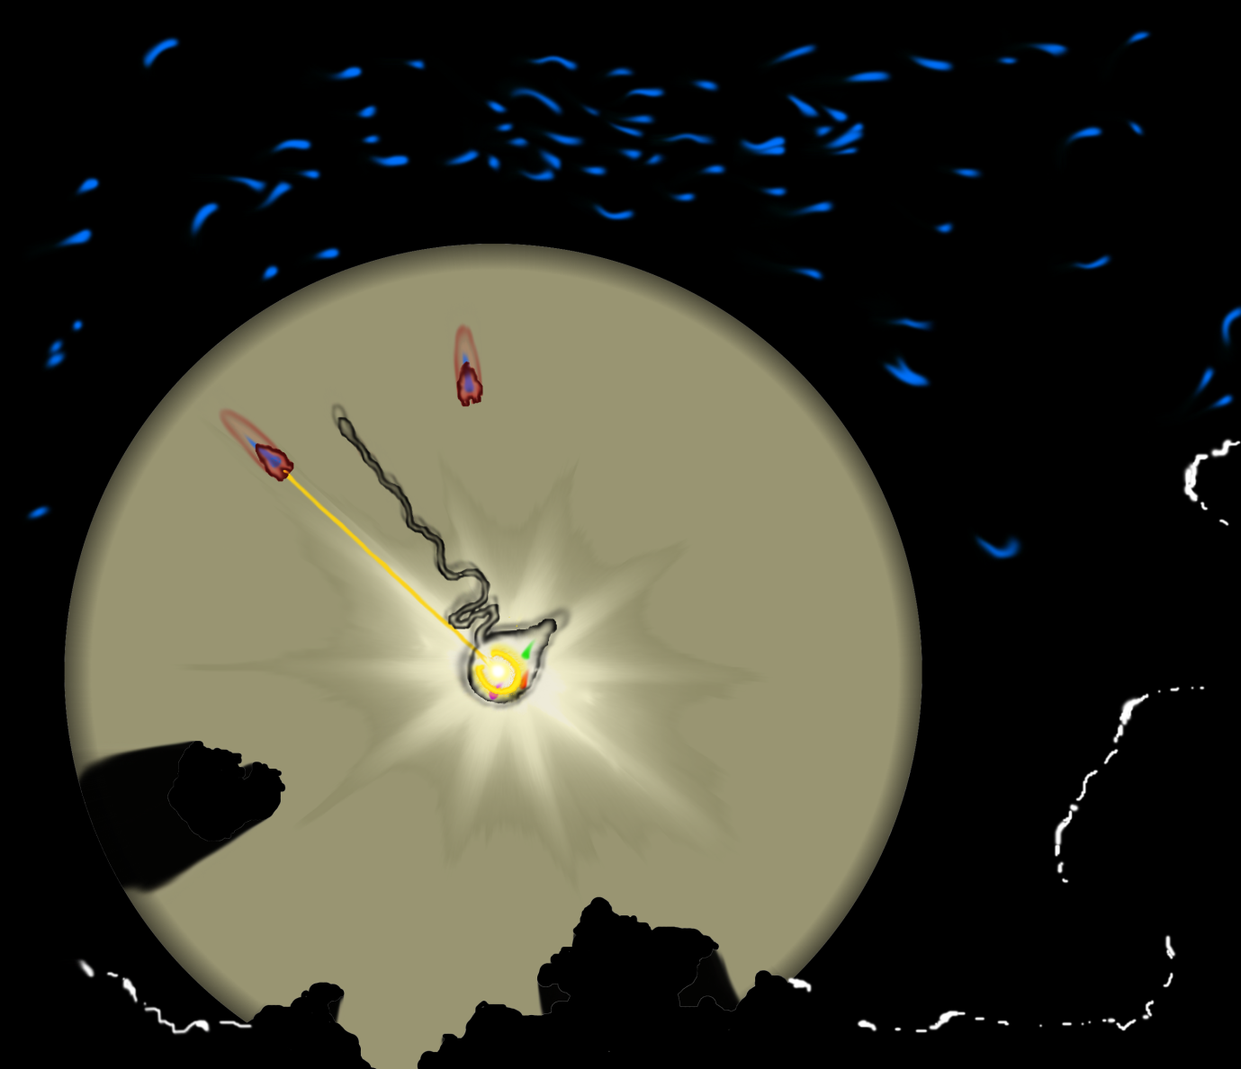

Mock-up of a typical game screen

Includes shadow-casting, caustics, soft-body physics, and terrain

The swarm in the dark is depicted by their blue glows, and the edges of the terrain can be made out by their white glows

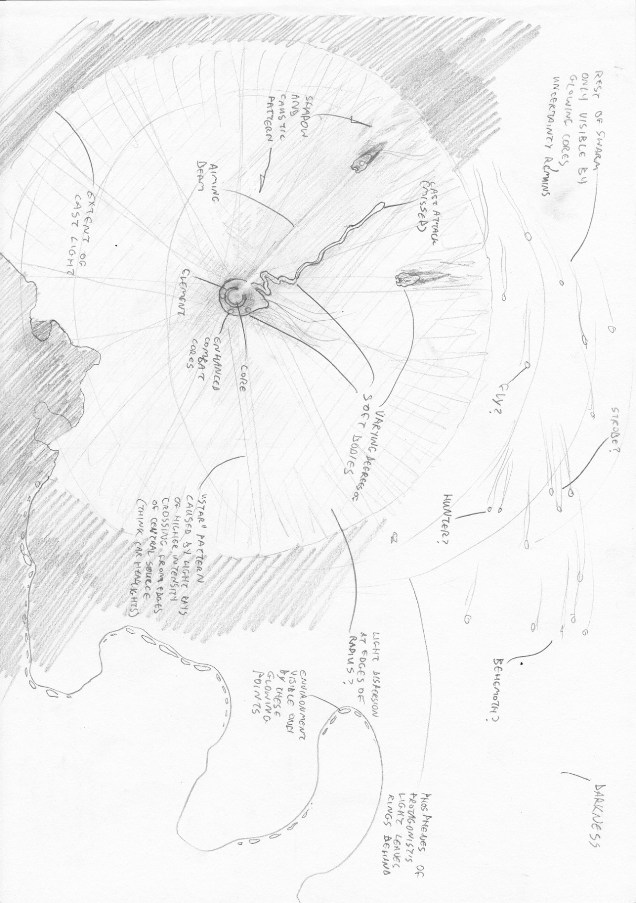An overall view of a typical game screen

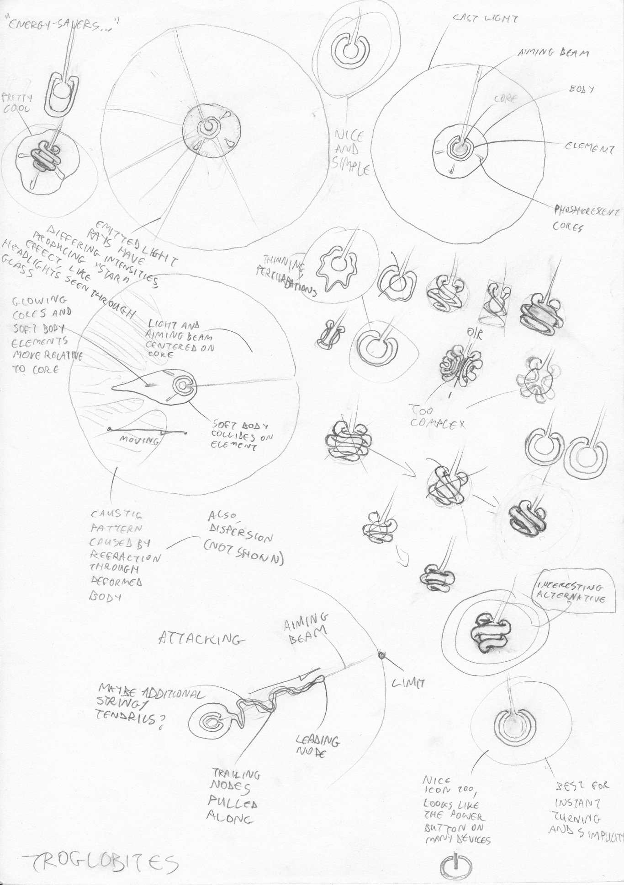The protagonist's details

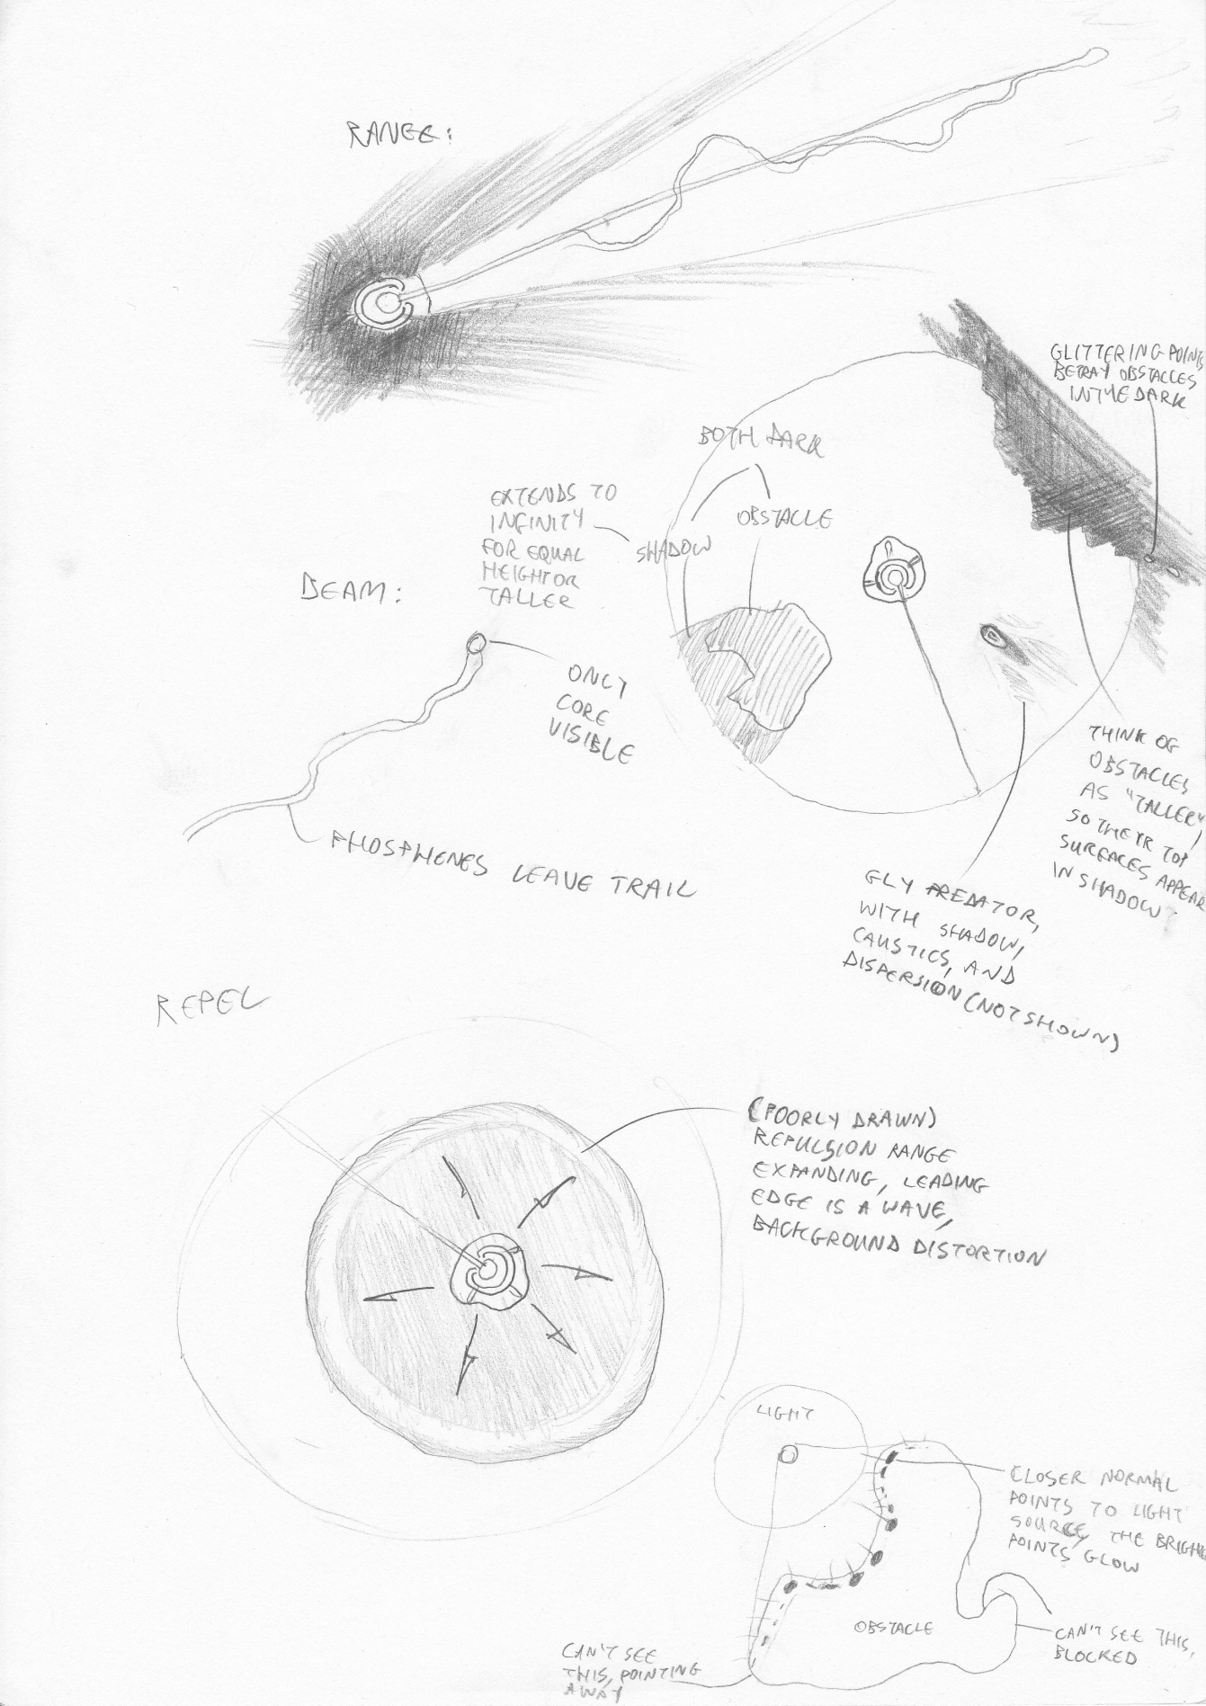Enhanced combat and other details

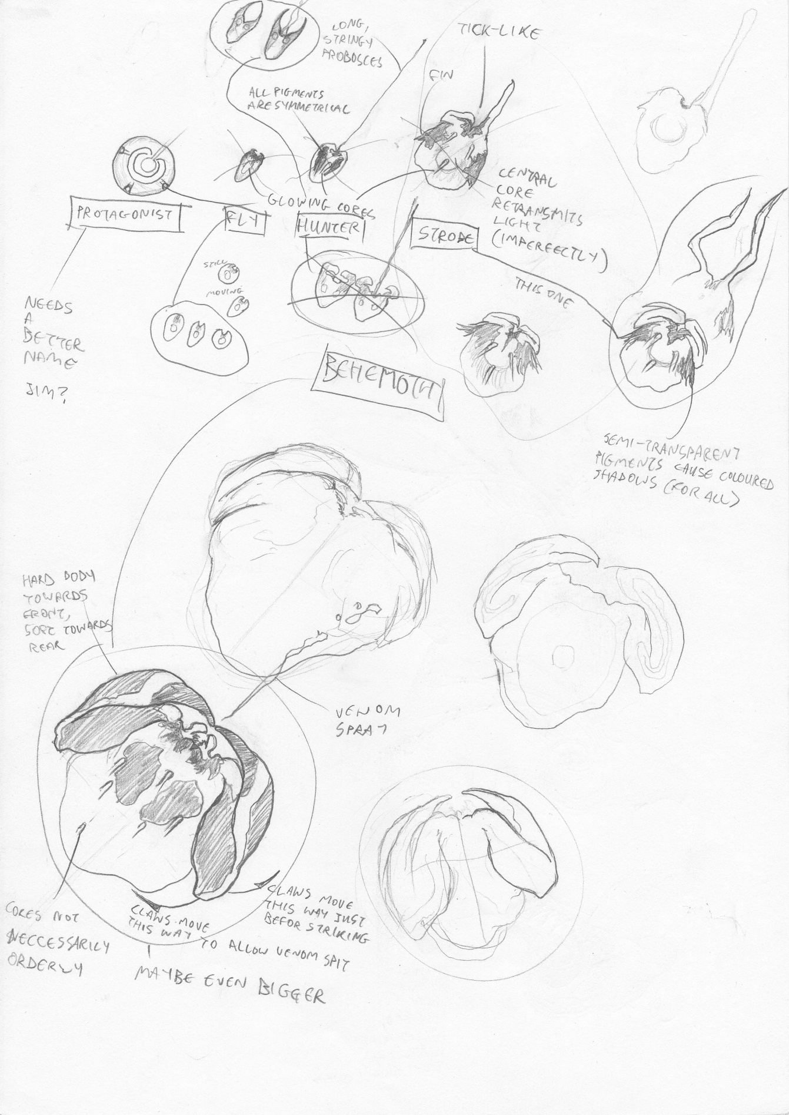Predators and relative scales

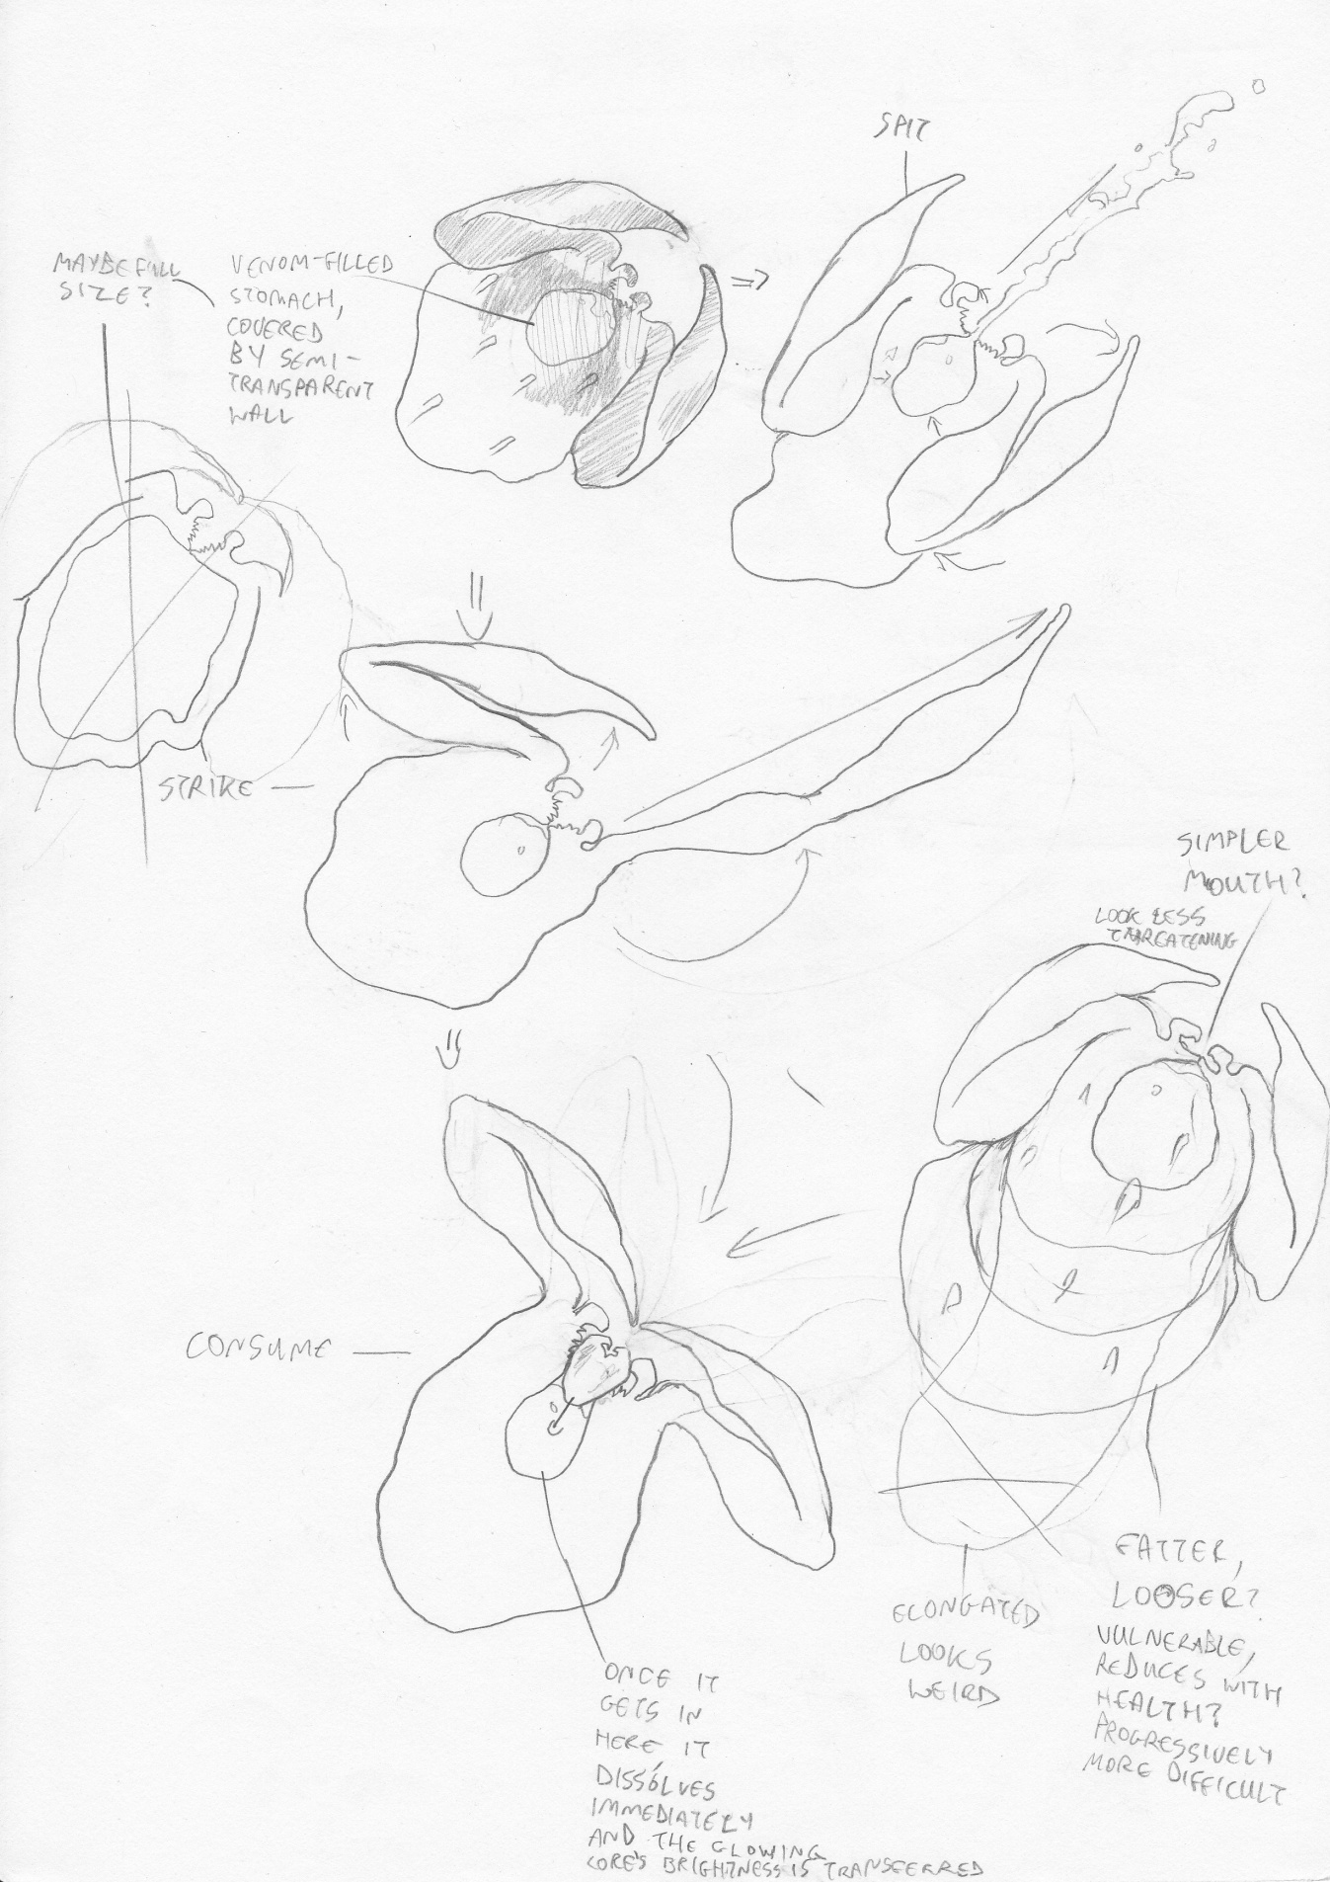Behemoth variations and attacks

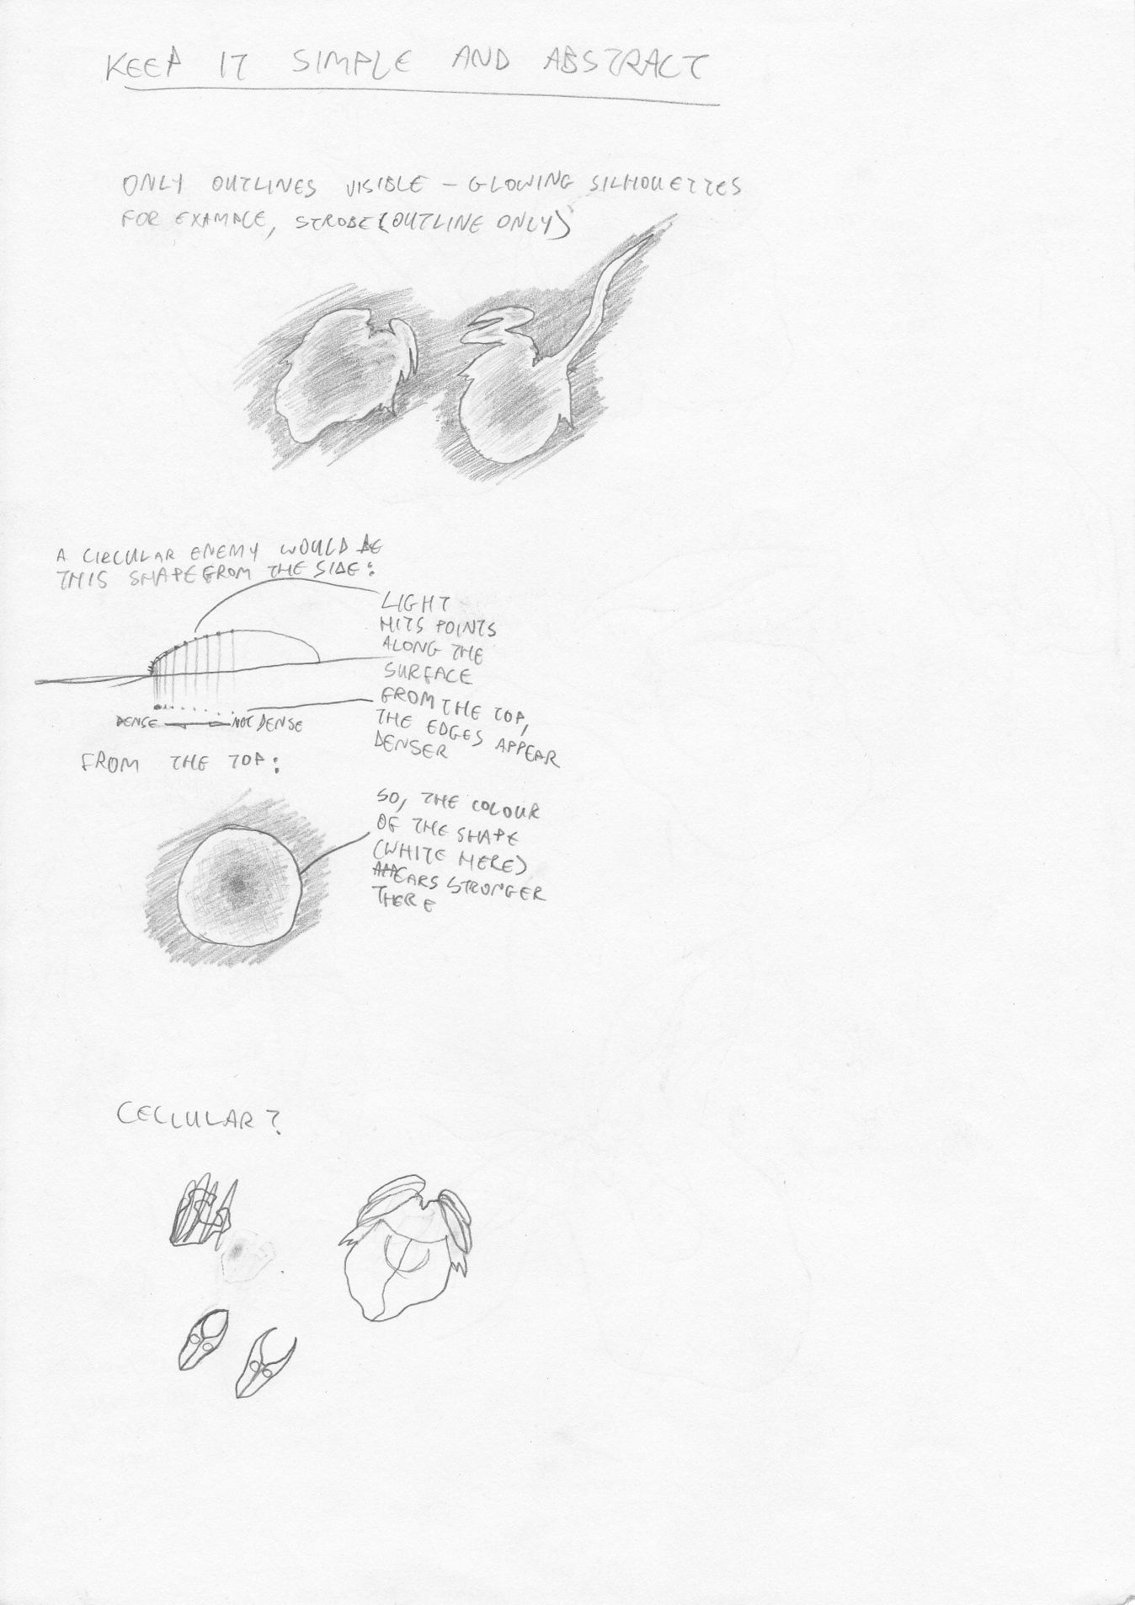General entity look and feel

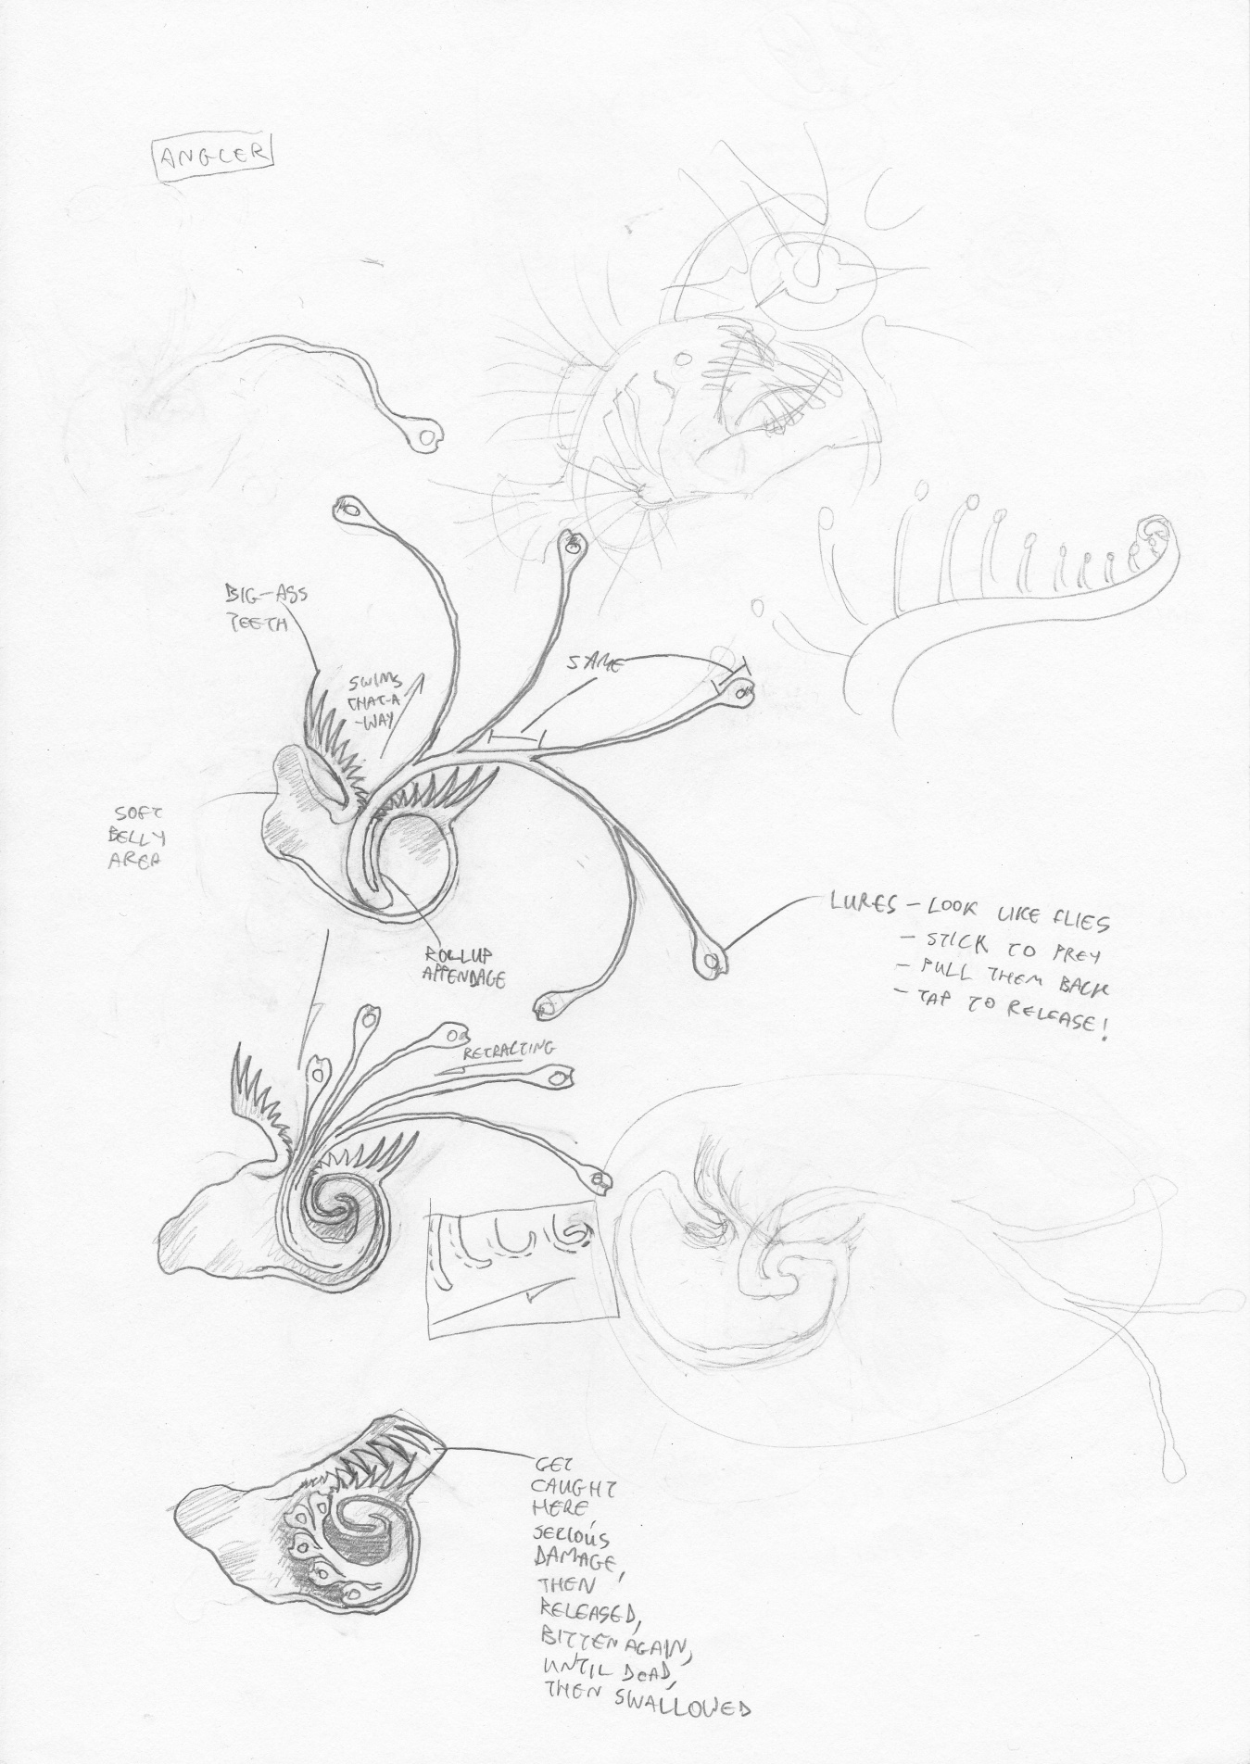An additional predator type, for further expansion – the Angler

1. TECHNICAL
2. Target Platforms and Considerations
   1. Modern Web Application

* The initial target, this will utilise recently emerging web technologies – WebGL, improved JavaScript engines, local storage, and other HTML5 innovations
* Lumens will be developed to the W3C specifications, and will not be not expected to run on browsers which do not correctly implement them (looking at you, Explorer), nor will great effort be spent on trying to make it work across a wide range of current and older browsers – the focus is on modern browsers
* It should, however, support a wide range of modern platforms which may access it, including mobile and touch-screen devices
* Speed and performance limitations are a major concern, since this is relatively new territory, and the project contains several computationally heavy components – flocking, real-time light simulation, dynamic audio, and other physics
  + Solutions to optimise performance on this and the other platforms will be discussed in further documents
  1. iOS
* The ideal solution would be to wrap an internal web browser context in a native application, with a communication interface between them to support persistence
* If this affects performance too severely, the context does not have the necessary features, or would violate the App Store Guidelines, then a full port may be required
* The App Store Guidelines and quality control measures must be closely adhered to
* Performance is an issue of even greater significance on mobile platforms
  1. PSP
* This platform will be aimed for as an attempt to make use of the access to development kits I have during the course of this project
* It will require a full port of the game, and very likely be a great challenge
  1. Android
* The considerations for this platform are similar to those for iOS, with the exception of the App Store Guidelines
  1. Windows
* A native Windows application would reduce the constraints on performance
* Implementing the existing web application (if it is successful) through a browser context may be a preferable option in terms of development time
  1. Mac OS
* A native Mac application has the same considerations as Windows, with the addition of the Mac App Store Guidelines

1. Development Environment
   1. Programming Languages

* JavaScript (with jQuery, Modernizr and Three.js), HTML (HTML5), CSS (CSS3, SCSS) – Web Application, fast prototyping
* GLSL – Shaders
* C, C++ – iOS, Mac, Windows, PSP
* Objective C – iOS, Mac
* Java – Android
* XML (or other platform-independent markup) – communication and persistence
  1. Software
* Sublime Text 2
* Chrome developer tools (and Webkit, Firebug, and other in-browser development tools)
* Visual Studio 2010/2008
* XCode 4
* GitHub
* Photoshop (and other asset-production software)
* WAMP Server
* Frameworks and libraries
  + jQuery/Prototype
  + Modernizr.js
  + Three.js
  + Node.js
  + Sony PSP development plugins for Visual Studio 2008
  + Cocos2D/Box2D
  1. Hardware
* Dell Studio 1558, Intel Q740 Core i7, 4GB RAM, Windows 7 Home Premium/Professional
* PSP development kit
* MacBook Pro (hopefully)

1. INITIAL PROJECT MANAGEMENT AND OBJECTIVES
2. Approach

* The project will be developed using an adaptive, iterative approach
* Working versions will be produced, incrementally adding features
* Adaptations will be made as the need arises and as reviews and reflections are carried out at each iteration
* The project may change substantially, in keeping with its general aims and themes

1. Iterations
   1. Game-play Mechanisms and Basic Physics

* Iteration 0.1 will be a demonstration of the game-play mechanics
  + Protagonist, with movement, health, and normal combat
  + Fly predator swarm, with full behaviours
  + Full core negative feedback loop in place
  + Initial game balancing
* It will include the minimum necessary physics and visual rendering required for this purpose
* The central modules will be established, and a modular application architecture will be in place for other components – rendering, user input, etc.
* This is the core of the project
  1. Basic Light Simulation
* Iteration 0.2 will begin exploring the basics of light simulation
  + Lighting
  + Shadow casting
  + Non-ray-traced phosphorescence
* Good performance and a scalable architecture must also be achieved
* This is the first phase of the real-time light simulation challenge
  1. Advanced Light Simulation
* Iteration 0.3 will achieve the advanced goals of the light simulation
  + Reflection, with bleeding colours
  + Refraction, with dispersion
  + Caustics, with sharp patterns
  + After-image
  + Crepuscular rays and volumetric light
  + Rays of varying intensity
  + Reaching a good approximate solution for the rendering equation
* Performance optimisations must be implemented
* This is the final phase of the real-time light simulation challenge
  1. Advanced Physics
* Iteration 0.4 will have in place a physics engine comprehensively covering the use-cases required in the game
  + Particles
  + Soft bodies, both “open” and “closed”
  + Rigid bodies
  + Collision detection and resolution engine
  + Approximated air-flow reaction for atmospheric particles
  + Magnetic attraction for collectibles
* This will be achieved in a modular, scalable physics engine
* This, along with flocking and lighting, is the third major technical milestone
  1. Further Variety in Game-play and Antagonists
* At the stage of Iteration 0.5, the other antagonists will all be fully integrated into the game
* The combat systems and artificial intelligence for the protagonist and antagonists will be in place
* Scoring and multipliers will largely be in place, recording and balanced
* The game-play and visual elements will have reached a fully working stage representative of the eventual release
  1. Dynamic Audio
* Full dynamic audio will arrive in Iteration 0.6
  + All audible events will produce sound and alter it suitably with variables
  + Sound pipeline/channel will be in place and managing all incoming requests
* This finishes out the core aesthetic elements of the game
  1. Stage Generation and Progression
* Iteration 0.7 will move the game from a demonstration mode to introduce advancement
* The stage generation module should generate reliable results for arbitrary arguments, and therefore be capable of producing a near-infinite variety of distinct stages
* Persistence will be introduced at this stage in relation to stage generation and retrieval
  1. Menu System
* Iteration 0.8 will adorn the game with the necessary trimmings for users to manage it, and support local user profiles
* Persistence will be completed to this local level
  1. Scores
* Iteration 0.9 will fully support user profiles
* Recording and retrieving scores, finishing off persistence
* Full necessary communications for the first target platform to manage user profiles via a server
  1. Tightening Up and First Platform Launch
* Any remaining major bugs will be removed, tweaks made, and a final rebalancing will be done before Iteration 1.0 is released for testing
* Pending testing and rebalancing, *Lumens* will be launched on its first platform, possibly commercially
  1. Revisions, Changes and Subsequent Platform Launches
* Iterations X.X will repeat as many of the above steps as necessary to secure releases on some or all of the target platforms
* Changes and enhancements are expected to take place during these stages
* The application may also require a commercial strategy, if the results are marketable, which will be explored later

PART II – IMPLEMENTATION CHALLENGES AND PROCESS

OVERVIEW

In the design phase, *Section VIII: 2*, targets for the iterative development of the project were laid out, which provided an idea of the priorities of the project – timelines were estimated after this as well, but its main purpose was to provide a general structure. The adaptive spirit of the development process would override these as more was learned during development, necessitating changes as some components would turn out to be dependent on others.

This adaptive methodology became important almost immediately during the development of the second prototype – iteration 0.1, developed under the revised system design with an improved approach to physics and architecture over the first prototype.

After setting up the framework of the project and achieving the basic milestones of that iteration – basic physics and rendering, predators with full swarming behaviours – it appeared that the implementation of the basic game-play should be postponed until basic shadow-casting was in place.

There were two reasons for this.

Real-time ray-tracing was the most interesting and challenging aspect of the project – after the basic skeleton was in place – and I wanted to tackle it immediately, to ensure it was addressed in some way before the final deadline. I would prefer to have faced some new challenge, learned something, and achieved something demonstrable from it; rather than have spent more time developing the same kind of thing I have before and discovering too late that the greater challenges required more time than I had remaining to overcome, leaving me with something I could have put together before ever starting this project.

It was a simple choice of addressing the biggest challenge first. The other components could be developed any time and so taken for granted, but the most difficult problems needed to be tackled first.

The opposing argument would be that introducing a basic working version of the game first and addressing the more complex issues later would have made it easier to communicate and demonstrate the idea, as well as test it; but I could already feel the time passing, and was eager to cut to the core issue as quickly as possible – I decide to get stuck straight into the interesting part.

The finished game would require accurate detection to check whether or not a predator was lit. This was a core aspect of the game – the player would not otherwise be able to use the environment as cover, which is absolutely necessary.

The system developed for a basic working prototype would not represent the finished article well, since it would not account for this important mechanic; and would also take more time to implement than I wished to spend, only to be largely replaced again later. In order to better represent the game-play flow as it would eventually be, I needed to use the GPU ray-tracing system to return this information.

Again, there is the opposing argument that even a simple prototype, not fully representative of the final product, would still serve to provide a sketch of the idea – but, in this particular case, I felt this component would be too important to leave out on a small time budget.

This was a key decision in changing the course of the project, but I stand by it, as I learned far more along this path than I would have from another. If this project was being developed for a client eager to see results early on, things would probably have been different; but I had a limited amount of time to get the most from this project for myself, and did so.

The overall course of development resulted in successful demonstration of the key motion and style of the game, a simplified shadow-casting system, and a more advanced system ready for further expansion on a more capable platform.

It achieved the goals laid out up to iteration 0.2 – without the full game-play prototype, as discussed above –including modular, extensible game architecture as designed; emergent behaviours, with up to 600 entities at one time running at interactive speeds; and sphere-based shadow-casting, developed from several sources and including a system for the dynamic passing of global data from CPU to GPU. There is also a more advanced ray-tracing system as per iteration 0.3 developed, though too heavy for the platform in use.

At the outset of development, I had hoped to reach iteration 0.4 or 0.5, but those speculated targets did not account for some of the unforeseen implementation difficulties encountered; so, considering this, I am reasonably content about the work achieved.

The following sections deal with the major areas tackled over the course of development and the process used; challenges encountered, research done, efforts made, and solutions arrived at; sample source code and detail on key points of interest; and thoughts, reflections, things learned and changes I would was I to do it all again.

1. FRAMEWORK
2. Core features
   1. Space-Partitioning System

It was evident early in the design process – after initial research into the emergent flocking behaviours (Reynolds, 2001), ray-tracing, and collision-detection – that a space-partitioning data structure would be vital to accelerating these operations. Such a system groups collections of entities together according to their positions in space, allowing entities that are near a certain position in space to be queried and retrieved without iterating over every entity and checking its position. This is a performance optimisation, but needed to be considered at the start of development, since so many things are based on it, and it would be more difficult to crowbar it into the system later on.

A quad-tree system seemed to be the most appropriate for the project (since most computation was done in two dimensions and the rest could be handled simply, an octree system was not required), and so I settled on an MIT-licensed JavaScript implementation (Chambers, 2012). This system was adapted further in order to better fit into the project, and to provide more functionality.

A core addition was a two-way system. The original implementation was designed for entities to only be added to the tree, and not removed or updated – instead, the entire tree was cleared and rebuilt with the updated entities at the start of every step. With careful ordering of operations, this system worked fine:

* Clear the tree
* Resolve each entity’s new position
* Place it in the tree
* Carry out operations which rely on the quad-tree
* Accumulate updates for the next step

That was, until the collision detection and resolution system was being developed, which both depended on the quad-tree and updated its entities’ positions, and so did not fit into this pattern. Therefore, a two-way system was added, which allowed entities to be removed and replaced without clearing the entire tree.

This was achieved by altering the clear function to accept individual and arrays of entities to be cleared, and to have the node check its sub-nodes to see if their entities could be merged back up the tree to itself; and by adding a new merge function to facilitate this.

…

clear: function(item) {

if(item) {

// Note: item here refers to the exact object stored in the tree

if($.isArray(item)) {

for(var i = 0; i < item.length; ++i) { this.clear(item[i]); }

}

else if(this.nodes.length) {

var node = this.nodesFor(item)[0];

if(node) {

if(node.nodes.length) { node.clear(item); }

else if(node.kids.remove(item)) {

var nodeKids = 0;

for(var l = 0; l < this.nodes.length; ++l) {

var nL = this.nodes[l];

// Don't merge if node still has subnodes

if(nL.nodes.length) {

nodeKids = Infinity;

break;

}

else { nodeKids += nL.kids.length; }

}

if(nodeKids <= this.maxKids) { this.merge(); }

}

else {

//log("QuadTree Warning: item to be cleared not …”);

}

}

}

else if(!this.kids.remove(item)) {

//log("QuadTree Warning: item to be cleared not found");

}

}

else {

this.kids.length = 0;

for(var n = 0; n < this.nodes.length; ++n) {

this.nodes[n].clear();

}

this.nodes.length = 0;

}

// For function chaining

return this;

},

…

merge: function() {

for(var n = 0; n < this.nodes.length; ++n) {

var node = this.nodes[n].merge();

this.kids = this.kids.concat(node.kids);

node.clear();

}

this.nodes.length = 0;

return this;

}

…

This ensured the desired number of entities was maintained in each node, and the quad-tree structure was adhered to; without containing duplicates, empty nodes, or other issues.

Upon reflection, a KD-Tree may have been a more effective system to use for this project, as its partitioning is more sophisticated than the quad-tree; however, the quad-tree implementation was quite effective, and served the purpose well, without overcomplication.

1. Challenges
   1. Design and Structure

Overall, the structure of the project was not a major issue. I found taking some time to think about and design it with tools like UML diagrams, or simply a pencil and paper, allowed me to clarify the direction I was going in – and avoid the tendency to wander aimlessly and miss the bigger picture.

* 1. JavaScript

I did find some issues programming a larger class structure in JavaScript, however. It is not a fully object-oriented language, but rather a prototypical one (one without classes); and I found that getting used to some familiar patterns – such as inheritance or template classes – was not always straightforward.

Being a very flexible dynamic language, the temptation often arose to simply make something up which to do the job … for now. However, there’s usually a proper way to achieve the desired result, which adheres to all the rules which may not have been immediately evident, but which inevitably mess up something down the line if not followed.

This sample code, for example, shows a function defined to encapsulate prototypical inheritance in a more convenient way:

function inherit(Child, Parent) {

Child.prototype = Object.create(Parent.prototype);

Child.prototype.constructor = Child;

return Child;

}

Best-practice methods from several sources (Mozilla, Resig; 2012) were collected, and this function was defined to conveniently and safely handle general prototypical inheritance in one place.

As with almost all of the JavaScript code in *Lumens*, the function returns the most useful object, to facilitate function-call-chaining and further reduce the verbosity of code. For example, a typical use would have a child class inherit from a parent, then extend the child’s prototype (using jQuery’s $.extend function) to add new functionality, or override the parent’s functionality:

// Parent “class” and constructor

function Parent(…) {…}

// Functionality added to parent’s prototype

$.extend(Parent.prototype, {…});

// Child class

function Child(…) {

…

// Call to super constructor

Parent.call(this, …);

…

}

// Inheritance and polymorphism (overridden functionality in the subclass)

$.extend(inherit(Child, Parent).prototype, {…});

Seeing the differences between a stricter language and a dynamic one was an interesting aspect of the process of development.

JavaScript will let you do a lot more, code awful things, and get away with it for a time. But it will punish you later with some obscure and inscrutable issue, often with unhelpful or even misleading indications of what’s gone wrong.

A stricter language, however, will only let you do things one way, and if you deviate from it, will complain until you fix it. But you are usually surer of where you stand with the program you’ve written.

Finding reliable references for JavaScript was very important, as for every right way to do something, there’s several wrong ones being used and shared. The Mozilla Developer Network (2012), became an invaluable resource, along with various accomplished web developers (Cabello, Irish, Hattab, Lewis, Resig; 2012), who’s work I often examined to guide my own.

1. Results and Reflection

The project framework was developed as shown in the following diagram (with some parts excluded for brevity, and the greyed out classes indicating those which have not yet been implemented).

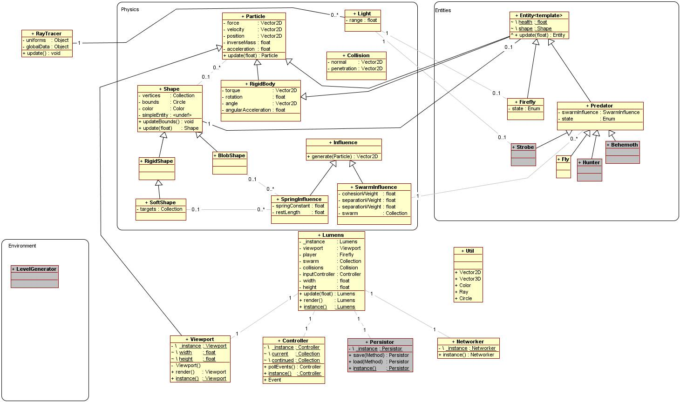

Some components were written according to the design and never implemented, such as the touch controller interface.

Overall – after some refactoring – it proved a solid structure, and was suitably constructed to allow additional elements to be introduced with relative ease.

1. PHYSICS
2. Engine

The physics engine was developed to the point of particle physics, adapted from the physics engine design of a practical mathematics course delivered in WIT, and Ian Millington’s *Game Physics Engine Development* (2007), its excellent primary source. Adapted from this material were Newtonian particle physics; force and impulse generators (springs and collision responses); and collision detection and resolution.

Some of these systems were adapted further from the existing engine, and others added, which we will examine in further detail – the rest is pretty close to the C++ implementation in the aforementioned reference material.

* 1. Collision Detection

The collision detection and resolution system went through a couple of iterations; initially trying to more closely follow Millington’s collective solving system.

This involved all collisions being detected and reported to a central handling system. This system would then iterate several times over all the collisions, resolving each pair and then rechecking them for collisions resulting from the first resolution – effectively “shuffling” multiple collisions apart over several steps, until the entire system had been resolved to a state of no collision.

It became apparent that this system would demand too many resources, impacting upon performance and development time, and was superfluous for the particular purposes of this project. So, it was then adapted into a simpler discrete system.

In this system, when a collision was detected, it was resolved immediately and over a single step for the two entities involved. Each entity was in turn updated and checked for collisions with its neighbours, so all entities were checked at least once.

This system forgoes some of the accuracy of Millington’s method, favouring performance. But it is fit for purpose in this case, since the number of entities on screen at any one time is a higher priority than exact physical accuracy.

The system was developed to the point of bounds-checking – responding to an entity’s bounding sphere, rather than its actual geometry – with the intention of continuing to geometry-checking if the ray-tracing system advanced sufficiently to make it worthwhile.

Up until the ray-traced iteration, entity bounding radii were checked against the actual geometry of the environmental obstacles.

* 1. Damped Springs

A simple adaptation of the standard spring force, with damping applied to oppose velocity in the direction of the end of the spring.

…

dampedSpring: function(options) {

// The normal spring force takes a Vec2D, not a Particle

var from = options.pointFrom.pos, oldFrom = options.posFrom;

options.posFrom = from;

//Apply the normal spring force

var spring = this.spring(options), damp;

if(from.equals(options.posTo)) {

damp = options.pointFrom.vel.scale(-options.damping);

}

else {

damp = from.sub(options.posTo).doUnit();

damp.doScale(-options.damping*Math.max(0,

options.pointFrom.vel.dot(damp)));

}

// Not using this any more

delete options.posFrom;

options.posFrom = oldFrom;

return damp.doAdd(spring);

},

…

* 1. Pressure Soft Bodies

The simplest approach to simulating a soft body is to create a mass aggregate model, constructed of particles attached by springs. This is liable to become unstable, however; and it can be difficult to get the balance correct between setting up enough springs in the right places for the shape to be stable, and not overburdening the simulation with too many (for example, from every particle in the model to every other particle).

So, after looking around for a better way, I read a paper about a pressure-based system (Matyka, 2004). Matyka describes the method as like having a gas-filled material, whose surface is composed of particles connected by spring, but which is kept inflated by the pressure of the gas within. Thus, each particle need only be connected to its direct neighbours (defining the shape’s surface), and not have strut springs connected to opposite particles. The separating force is pressure instead – calculated once and applied equally to all particles – far more efficient than several spring forces.

In order to calculate the pressure force, the volume of the body is approximated using Gauss theorem – based on the surface of the body rather than its actual volume.

…

applyPressure: function(points, density) {

// Derived used to prevent repeated calculations

var volume = 0, derived = [];

// Gauss theorem for approximating volume

for(var p = 0; p < points.length; ++p) {

var from = points.wrap(p-1), to = points[p],

vec = to.pos.sub(from.pos),

mag = vec.mag();

if(mag) {

var normal = vec.perp().doScale(1/mag);

volume += 0.5*Math.abs(vec.x)*mag*Math.abs(normal.x);

derived.push({ from: from, to: to, mag: mag, normal: normal});

}

}

var invVolume = 1/volume;

for(var d = 0; d < derived.length; ++d) {

// Apply pressure

var data = derived[d], pressure = invVolume*density*data.mag;

data.from.force.doAdd(data.normal.scale(pressure));

data.to.force.doAdd(data.normal.scale(pressure));

}

}

1. Results and Reflection

The physics engine as a whole worked very well eventually. It’s still quite a simple affair, without rigid body simulation, a more robust collision system, or geometry-level checking for most entities. However, it was able to simulate up to around 600 entities at a time (probably more if other features had been disabled) at interactive rates of 25-35 fps. Seeing hundreds of swarming entities flowing around the screen, colliding and interacting with the environment and one another in real time was quite rewarding.

However, it took a considerable amount of refactoring and small optimisations to get it running at that rate. The quad-tree system was invaluable, but there were many smaller changes that needed to be made, and considerations to be made for the way JavaScript works, for example:

* Caching variables (keeping direct references to properties of other objects used repeatedly) is important, since the process of resolving a query for a property can be expensive in JavaScript
* Guarding as many operations as possible with conditional breaks and early exit opportunities proved to save a lot in terms of performance

The process of researching and implementing the physics engine and related features was, for the most part, a very interesting and engaging one – seeing the clever processes devised by the authors of the resources I studied made for very good reading.

Though it was not used in the main prototypes in the end, just its own test, the pressure soft body simulation was particularly interesting.

Another enjoyable application of the engine was the viewport – attached to the protagonist by a damped spring, and colliding with the sides of the level area when small enough to fit within them, it resulted in quite a nice, smooth camera panning motion.

1. ARTIFICIAL INTELLIGENCE
2. Implementation
   1. Swarm

A core part of the concept of *Lumens* is the swarming behaviour of the predators. The algorithm is a very famous, and fascinatingly simple one – Craig Reynolds’ “Boids” (2001).

Having covered this ground before in the first prototype, a few things had become apparent:

* The first version was limited to fewer entities than I would like, and so the quad-tree system would be a necessity to bring the algorithm down from On2 to something which would scale better
* There was a very simple logical error in the first attempt, which produced some oddly predictable behaviour (this was overlooked for longer than I would like to admit)

The main point of note here is that the first prototype revealed the necessity of a space-partitioning data structure, which is why the project was redesigned with that in mind.

The algorithm itself was quite trivial to implement (Buckland, 2005; Brundage, 2011), with some optimisations to reduce the number of computations where possible, and other minor changes (such as calculating from a point some way towards the entity’s future position:

…

swarm: function(options) {

var totalSeparation = new Vec2D(), totalCohesion = new Vec2D(),

totalAlignment = new Vec2D(), swarm = new Vec2D(),

predict = (options.predict || 0),

// Aim ahead of current position

focus = options.member.vel.scale(predict)

.doAdd(options.member.pos),

// Query the QuadTree

nearby = options.swarm.get((new Circle(focus,

options.nearbyRad)).containingAARect()),

num = 0;

for(var n = 0; n < nearby.length; ++n) {

var near = nearby[n].item;

if(options.member !== near) {

var nearbyFocus = near.vel.scale(predict)

.doAdd(near.pos),

vec = focus.sub(nearbyFocus),

dist = vec.mag();

if(dist < options.nearbyRad) {

++num;

var distFactor = options.nearbyRad/dist;

totalSeparation.doAdd(vec.doUnit()

.doScale(distFactor*distFactor));

totalCohesion.doAdd(nearbyFocus).doSub(focus);

var alignment = (near.angle || ((near.vel.magSq())?

near.vel.unit() : null));

if(alignment) { totalAlignment.doAdd(alignment); }

}

}

}

if(num) {

// Calculate averages

swarm.doAdd(totalSeparation.doScale(options.weight.separation))

.doAdd(totalCohesion.doScale(options.weight.cohesion))

.doAdd(totalAlignment.doScale(options.weight.alignment))

.doScale(1/num);

}

return swarm;

},

…

* 1. Wander

The wander force is a simple adaptation of Mat Buckland’s (2005), in which a circle is projected ahead of the entity, and a random point along its circumference selected as a target position. This results in a smooth, fishlike meandering, which serves a few purposes:

* Keeping isolated entities moving
* Making their movements look more interesting
* Adding some instability to the swarm behaviour, allowing entities to break away and increasing unpredictability

…

wander: function(options) {

/* range is proportional to the distance either side of the current

heading within which the entity may wander (radius of wander circle)

vel is the minimum velocity vector which wandering may produce

(distance wander circle is ahead of the entity) */

var angle = Math.random()*2*Math.PI;

return options.vel.add(new Vec2D(options.range*Math.cos(angle),

options.range*Math.sin(angle)));

},

…

* 1. Obstacle Avoidance

Similarly to the wander and swarm behaviours, a circle of influence is projected some way towards the entity’s next position.

This circle is checked for collisions with nearby environmental obstacles, and a force proportional to the square of the collision’s penetration is applied along the normal of the collision, steering the entity away from the wall before it hits it, and growing exponentially the closer the entity is to the wall.

…

avoidWalls: function(options) {

var force = new Vec2D(),

predict = (options.predict || 0),

focus = new Circle(options.point.vel.scale(predict)

.doAdd(options.point.pos), options.radius),

nearby = options.walls.get(focus.containingAARect());

for(var w = 0; w < nearby.length; ++w) {

var wall = nearby[w].item,

shape = wall.shape;

if(shape.boundRad.intersects(focus)) {

var verts = shape.three.geometry.vertices;

for(var v = 0; v < verts.length; ++v) {

var a = shape.globPos(verts.wrap(v-1).position),

b = shape.globPos(verts[v].position),

c = Collision.Circle.checkLine(focus, a, b);

if(c) {

// Inverse square force (already divided by pen)

force.doAdd(c.vector.scale(c.penetration));

}

}

}

}

if(options.lumens) {

var lc = Collision.Lumens.checkRect(options.lumens,

focus.containingAARect());

if(lc) {

lc.doSwap();

// Inverse square force

force.doAdd(lc.vector.scale(lc.penetration));

}

}

return force;

},

…

* 1. Scheduling System

Because some of the AI operations are expensive – swarming and obstacle avoidance in particular – and not as time-sensitive as physics or other concerns, a scheduling system was put in place to control and reduce the number of times these operations would be called.

function Schedule(wait, last) {

this.wait = (wait || 0);

this.last = (last || 0);

}

$.extend(Schedule.prototype, {

check: function(time) { return (time-this.last >= this.wait); },

copy: function(other) {

if(other) {

this.wait = other.wait;

this.last = other.last;

return this;

}

else { return new this.constructor(this.wait, this.last); }

}

});

…

…

// In Predator’s update function

if(this.swarm.schedule.check(time)) {

// Contributes to the predator’s guiding force

this.swarm.force = Force.swarm(this.swarm);

this.swarm.schedule.last = time;

}

…

…

This system is simple and easily tested and controlled for best results.

1. Results and Reflection

Using a live tweaking tool (dat.GUI, 2012) and a lot of time to balance it, the AI system produced some very nice results; with hundreds of predators flowing around the environmental obstacles, separating and joining their neighbours in the swarm in a very natural-looking way; all at interactive rates – once switched to the basic Three.js WebGL renderer, the number of entities on-screen at a time at stable and interactive rates increased from about 400 to about 600.

Due to prioritising the ray-tracing part of the project after achieving the basic physics and swarming behaviour, the AI behaviour trees and states were not implemented, since they would not be used until after that had been achieved – in any case, I felt the ray-tracing component was the more challenging and interesting aspect.

Overall, the results were very satisfying.

1. RAY-TRACING
2. REFLECTION

REFERENCES

Reynolds, Craig, 2001 (online), “*Boids: Background and Update*”, red3d.com, accessed 10.10.2011, URL: <http://www.red3d.com/cwr/boids/>

Buckland, Mat, 2005, “Programming Game AI by Example”, “Chapter 3: How to Create Autonomously Moving Game Agents: Group Behaviours”

Owen, G. Scott, 1999 (online), “*Ray Tracing*”, siggraph.org, accessed 16.10.2011, URL: <http://www.siggraph.org/education/materials/HyperGraph/raytrace/rtrace0.htm>

Wikipedia, 2011 (online), “*Ray Tracing (graphics)*”, en.wikipedia.org, accessed 16.10.2011, URL: <http://en.wikipedia.org/wiki/Ray_tracing_(graphics)>

Baldwin, Mark, 2005 (online), Baldwin Consulting, baldwinconsulting.org, accessed 15.10.2011, URL: [www.baldwinconsulting.org](http://www.baldwinconsulting.org)

jQuery, 2012 (online), www.jquery.com, accessed 28.11.2011, URL: <http://jquery.com/>

Modernizr, 2012 (online), www.modernizr.com, accessed 28.11.2011, URL:

<http://www.modernizr.com/>

HTML5 Boilerplate, 2012 (online), www.html5boilerplate.com, accessed 28.11.2011, URL:

<http://html5boilerplate.com/>

Three.js, 2012 (online), github.com, accessed 3.2.2012, URL: <https://github.com/mrdoob/three.js>

Chambers, Mike, 2011 (online), *“JavaScript QuadTree Implementation”*, mikechambers.com, accessed 15.12.2011, URL: <http://www.mikechambers.com/blog/2011/03/21/javascript-quadtree-implementation/>

Mozilla Developer Network, 2012 (online), developer.mozilla.org, accessed 16.4.2012, URL: <https://developer.mozilla.org/en-US/>

Cabello, Ricardo, 2012 (online), mrdoob.com, accessed 16.4.2012, URL: <http://mrdoob.com/>

Irish, Paul, 2012 (online), paulirish.com, accessed 16.4.2012, URL: <http://paulirish.com/>

Hattab, Hakim El, 2012 (online), hakim.se, accessed 16.4.2012, URL: <http://hakim.se/experiments>

Lewis, Paul, 2012 (online), aerotwist.com, accessed 16.4.2012, URL: <http://aerotwist.com/>

Resig, John, 2012 (online), ejohn.org, accessed 16.4.2012, URL: <http://ejohn.org/>

Millington, Ian, 2007, *“Game Physics Engine Development”*, chapters 3-7, published by Morgan Kaufmann Publishers

Matyka, Maciej, 2004 (online), panoramix.ift.uni.wroc.pl/~maq/ , *“How to Implement a Pressure Soft Body Model”*, accessed 12.2.2012, URL: <http://panoramix.ift.uni.wroc.pl/~maq/soft2d/howtosoftbody.pdf>

Brundage, Harry, 2011 (online), harry.me, *“Neat Algorithms - Flocking”*, accessed 8.11.2011, URL: <http://harry.me/2011/02/17/neat-algorithms---flocking>

dat.GUI, 2012 (online), chromeexperiments.com, *“dat.GUI”*, accessed 8.3.2012, URL: <http://workshop.chromeexperiments.com/examples/gui/#1--Basic-Usage>

Timothy J. Purcell, Ian Buck, William R. Mark, Pat Hanrahan, 2002 (online), *“Ray Tracing on Programmable Graphics Hardware”*, graphics.stanford.edu, accessed 16.4.2011, URL: <http://graphics.stanford.edu/papers/rtongfx/rtongfx.pdf>